**Kushagra Rastogi**

**304640248**

**ECE 219**

**Project 5: Application – Twitter Data**

**QUESTION 1:**











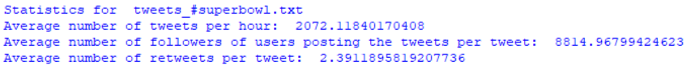

**QUESTION 2:**

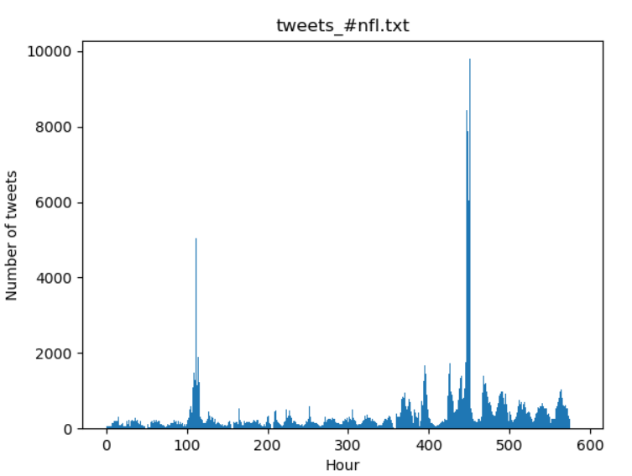

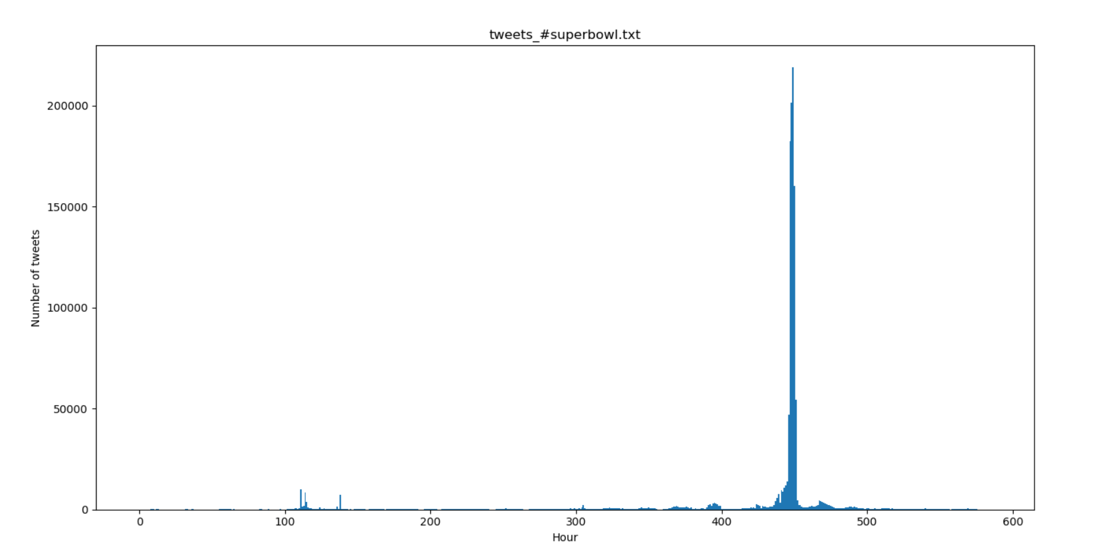

**QUESTION 3:**

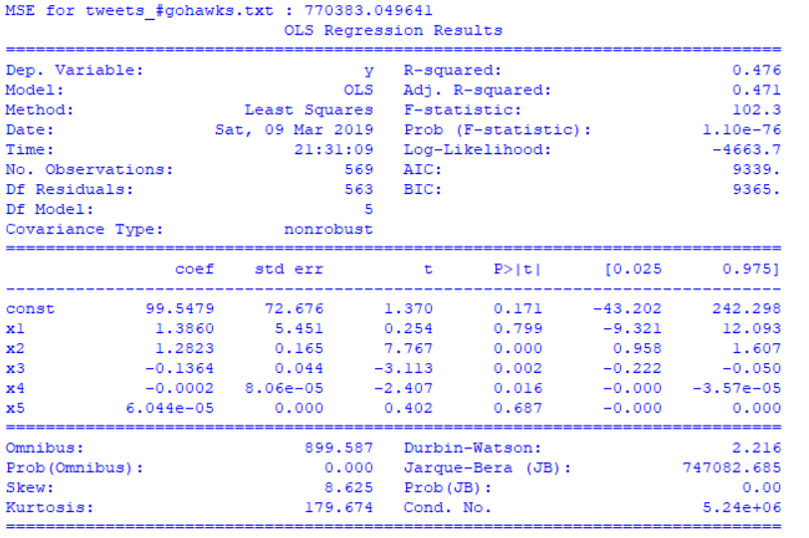

Variables are significant if their p-values are less than 0.05. This means that x2, x3 and x4 are significant. These variables correspond to number of tweets, total number of retweets and sum of number of followers of the user.

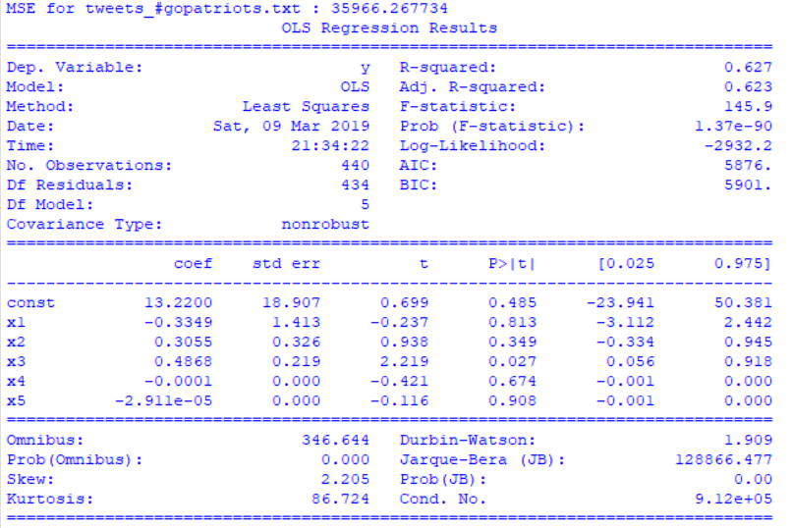

Variables are significant if their p-values are less than 0.05. This means that x3 is significant. This variable corresponds to total number of retweets.

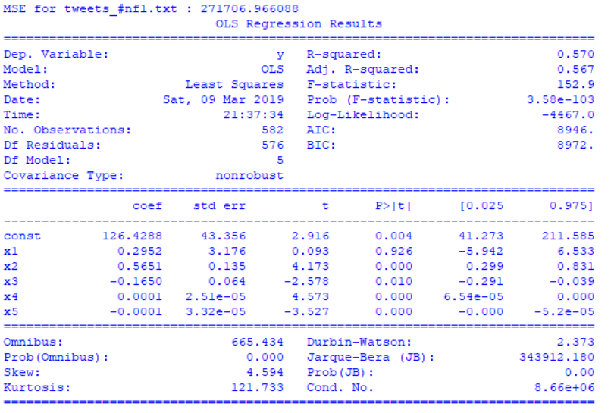

Variables are significant if their p-values are less than 0.05. This means that x2, x3, x4 and x5 are significant. These variables correspond to number of tweets, total number of retweets, sum of number of followers of the user and the maximum number of followers of the user.

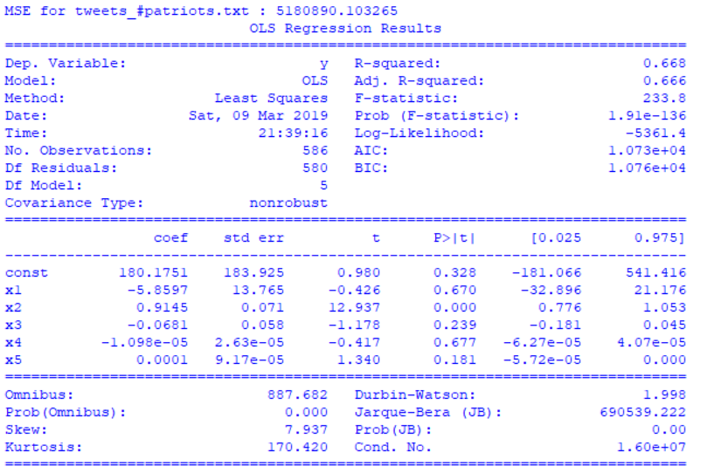

Variables are significant if their p-values are less than 0.05. This means that x2 is significant. This variable corresponds to number of tweets.

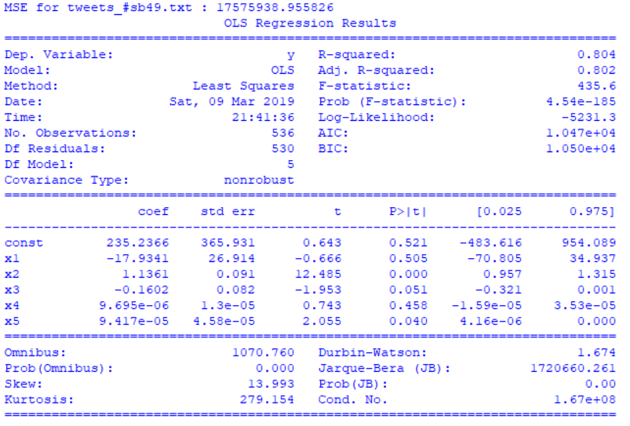

Variables are significant if their p-values are less than 0.05. This means that x2 and x5 are significant. These variables correspond to number of tweets and the maximum number of followers of the user.

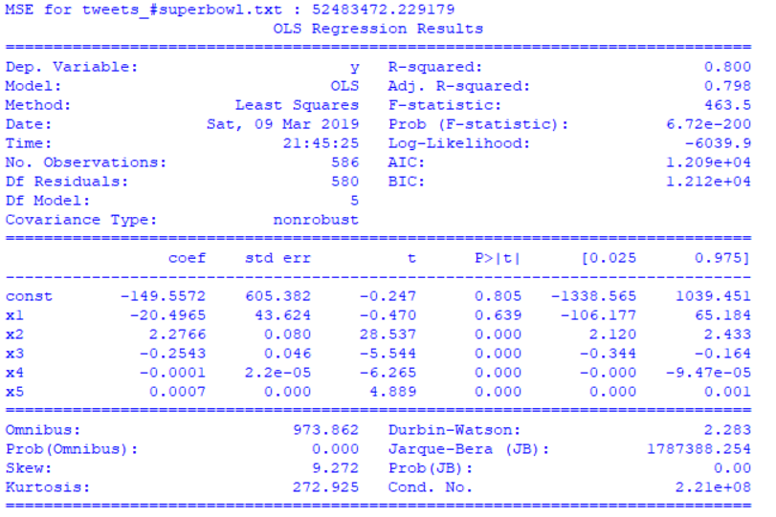

Variables are significant if their p-values are less than 0.05. This means that x2, x3, x4 and x5 are significant. These variables correspond to number of tweets, total number of retweets, sum of number of followers of the user and the maximum number of followers of the user.

**QUESTION 4:**

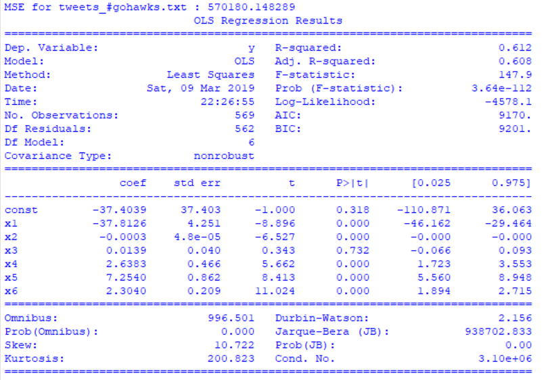

Variables are significant if their p-values are less than 0.05. This means that x1, x2, x4, x5 and x6 are significant. These variables correspond to number of tweets, sum of followers, sum of mentions, ranking score of the tweet and sum of hashtags.

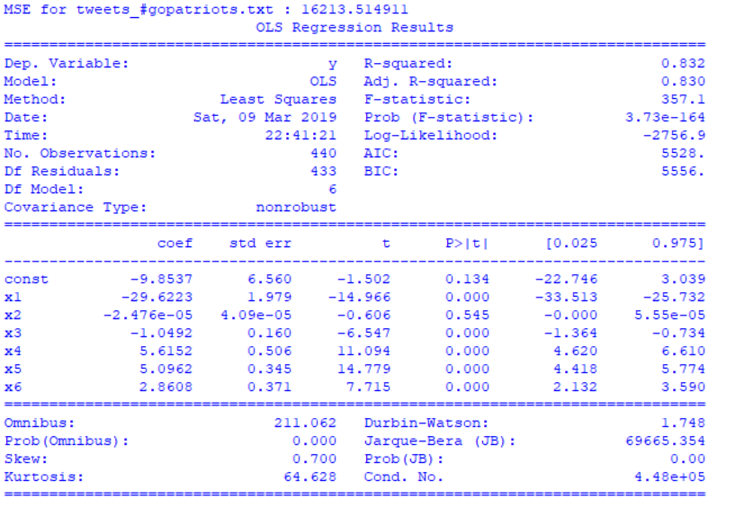

Variables are significant if their p-values are less than 0.05. This means that x1, x3, x4, x5 and x6 are significant. These variables correspond to number of tweets, total number of retweets, sum of mentions, ranking score and sum of hashtags.

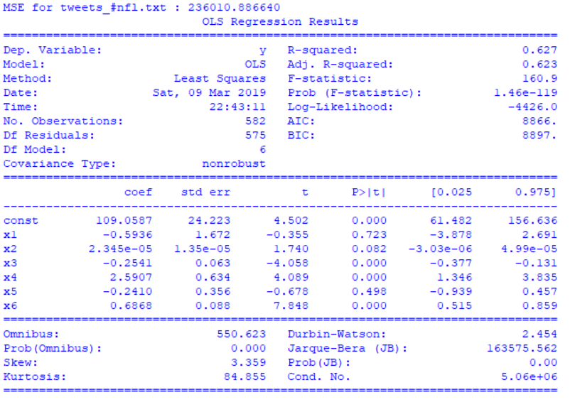

Variables are significant if their p-values are less than 0.05. This means that x3, x4 and x6 are significant. These variables correspond to total number of retweets, sum of mentions and sum of hashtags.

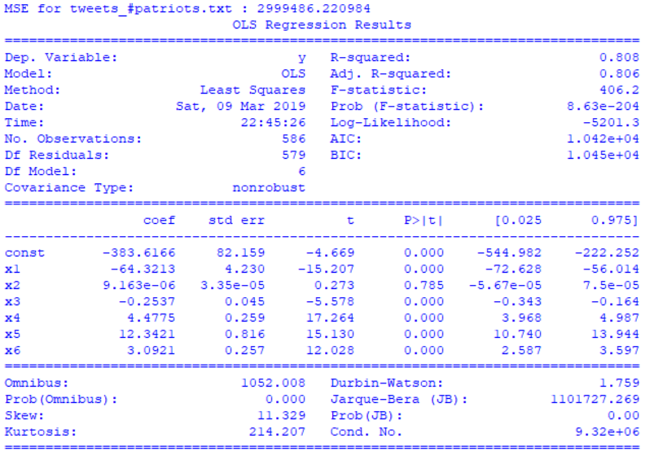

Variables are significant if their p-values are less than 0.05. This means that x1, x3, x4, x5 and x6 are significant. These variables correspond to number of tweets, total number of retweets, sum of mentions, ranking score and sum of hashtags.

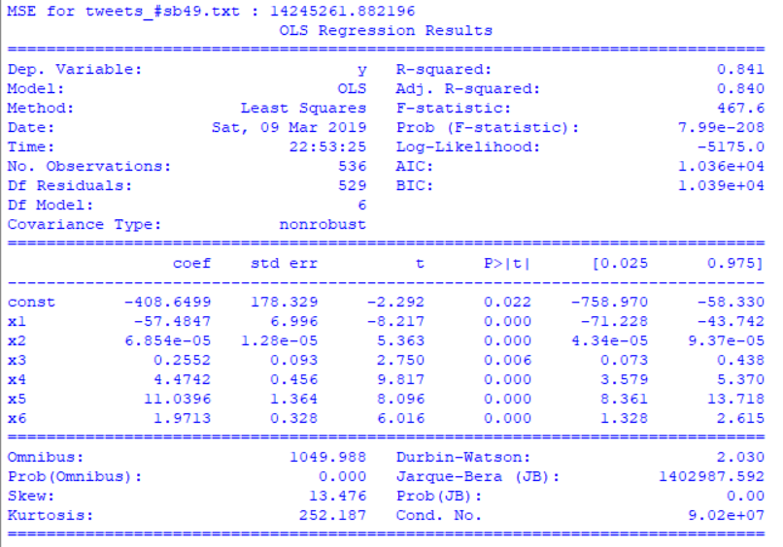

Variables are significant if their p-values are less than 0.05. This means that all variables are significant. These variables correspond to number of tweets, sum of followers, total number of retweets, sum of mentions, ranking score and sum of hashtags.

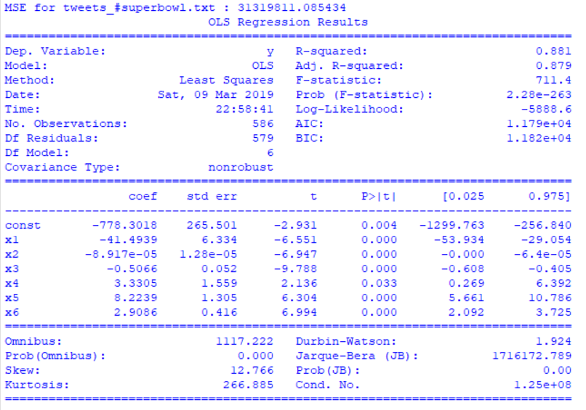

Variables are significant if their p-values are less than 0.05. This means that all variables are significant. These variables correspond to number of tweets, sum of followers, total number of retweets, sum of mentions, ranking score and sum of hastags.

**QUESTION 5:**

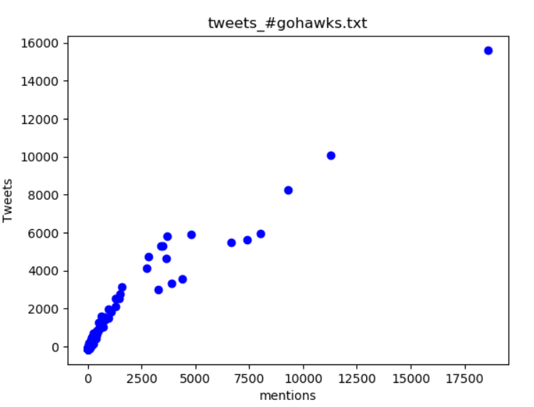

The regression coefficient is positive and the points on the graph follow a positive, linear relationship. Thus, the regression coefficient agrees with the trend in the plot.

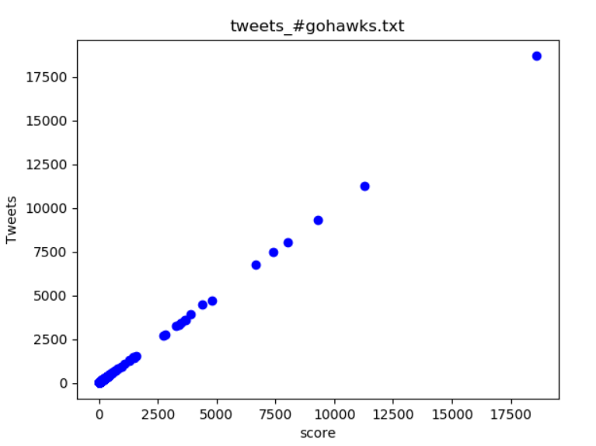

The regression coefficient is positive and the points on the graph follow a positive, linear relationship. Thus, the regression coefficient agrees with the trend in the plot.

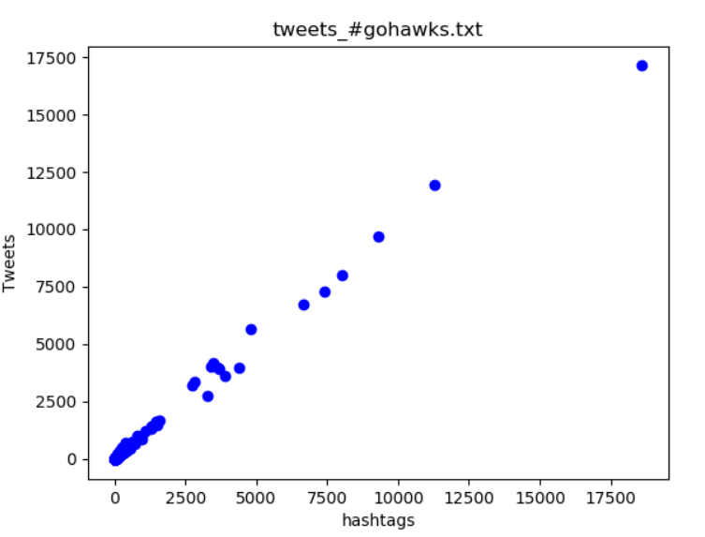

The regression coefficient is positive and the points on the graph follow a positive, linear relationship. Thus, the regression coefficient agrees with the trend in the plot.

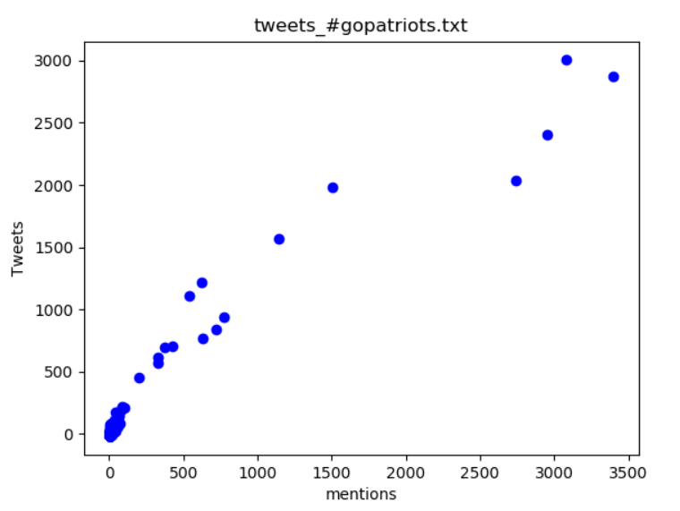

The regression coefficient is positive and the points on the graph follow a positive, linear relationship. Thus, the regression coefficient agrees with the trend in the plot.

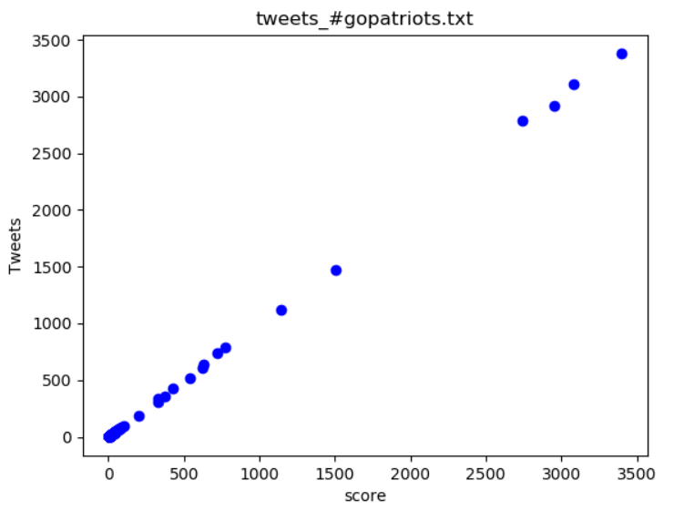

The regression coefficient is positive and the points on the graph follow a positive, linear relationship. Thus, the regression coefficient agrees with the trend in the plot.

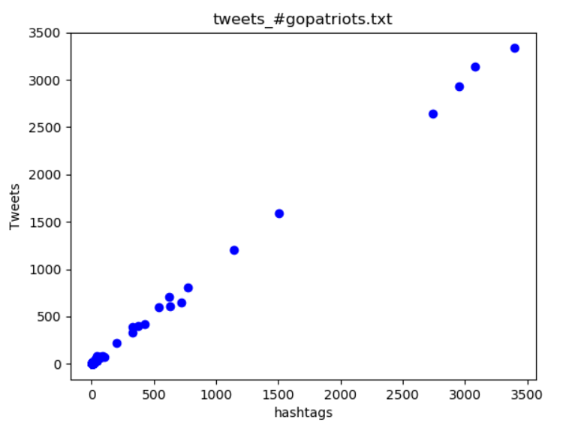

The regression coefficient is positive and the points on the graph follow a positive, linear relationship. Thus, the regression coefficient agrees with the trend in the plot.

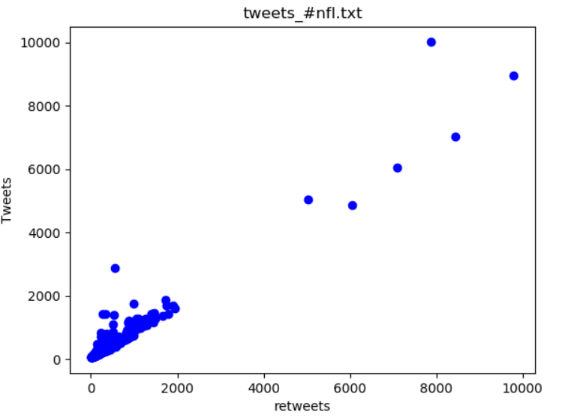

The regression coefficient is negative. However, the points on the graph follow a positive, linear relationship. Thus, the regression coefficient does not agree with the trend in the plot. This is because the regression analysis was run with several variables instead of just one. Hence, the regression coefficient does not reflect the true impact of one single variable.

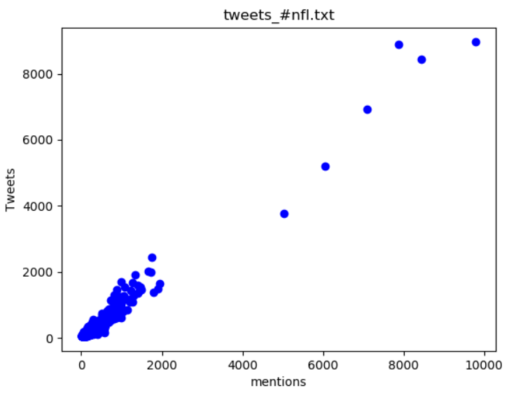

The regression coefficient is positive and the points on the graph follow a positive, linear relationship. Thus, the regression coefficient agrees with the trend in the plot.

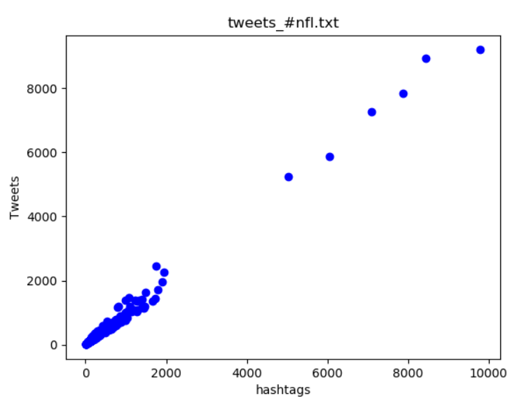

The regression coefficient is positive and the points on the graph follow a positive, linear relationship. Thus, the regression coefficient agrees with the trend in the plot.

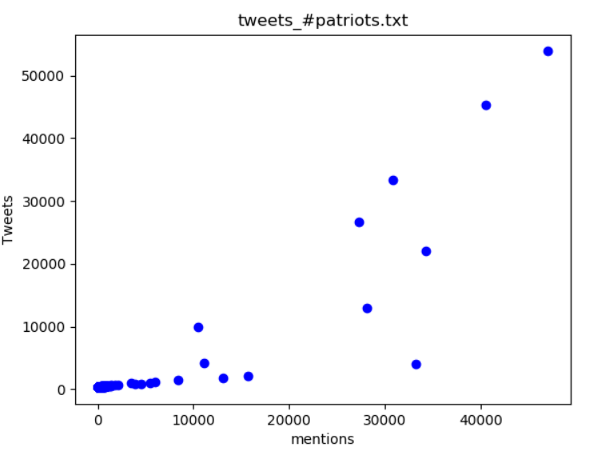

The regression coefficient is positive and the points on the graph follow a positive, somewhat-linear relationship. Thus, the regression coefficient agrees with the trend in the plot.

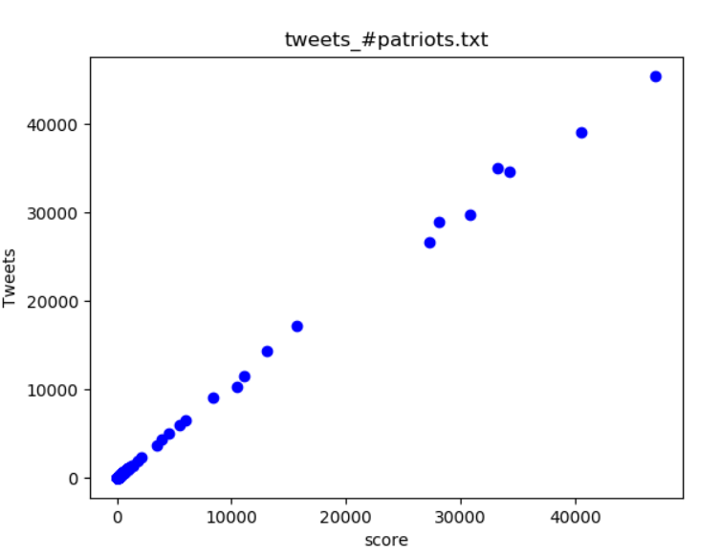

The regression coefficient is positive and the points on the graph follow a positive, linear relationship. Thus, the regression coefficient agrees with the trend in the plot.

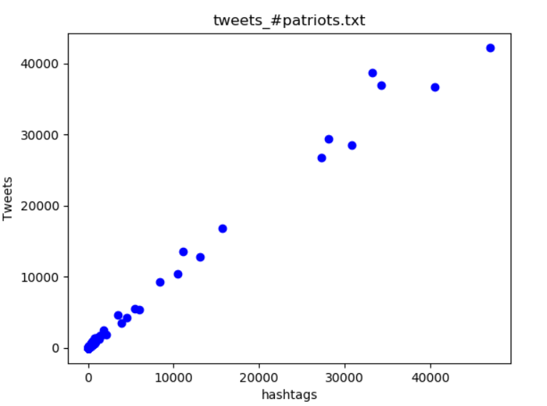

The regression coefficient is positive and the points on the graph follow a positive, linear relationship. Thus, the regression coefficient agrees with the trend in the plot.

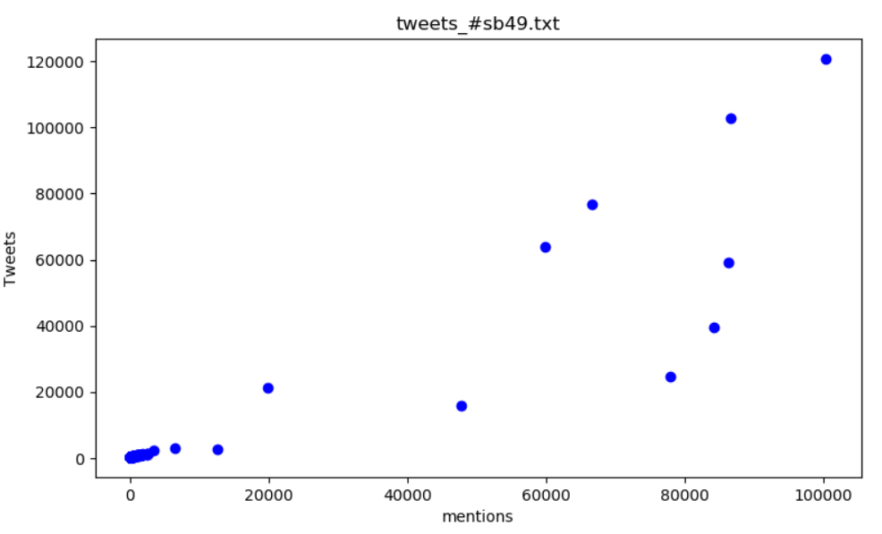

The regression coefficient is positive and the points on the graph follow a positive, somewhat-linear relationship. Thus, the regression coefficient agrees with the trend in the plot.

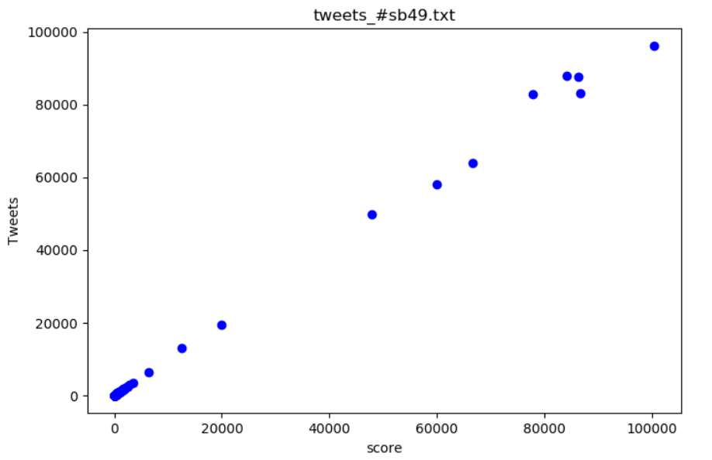

The regression coefficient is positive and the points on the graph follow a positive, linear relationship. Thus, the regression coefficient agrees with the trend in the plot.

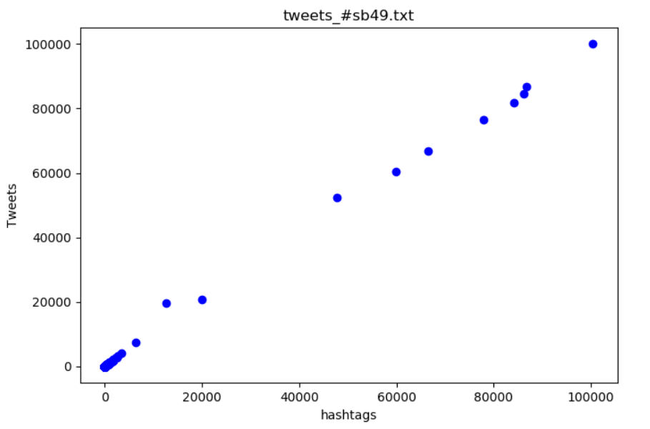

The regression coefficient is positive and the points on the graph follow a positive, linear relationship. Thus, the regression coefficient agrees with the trend in the plot.

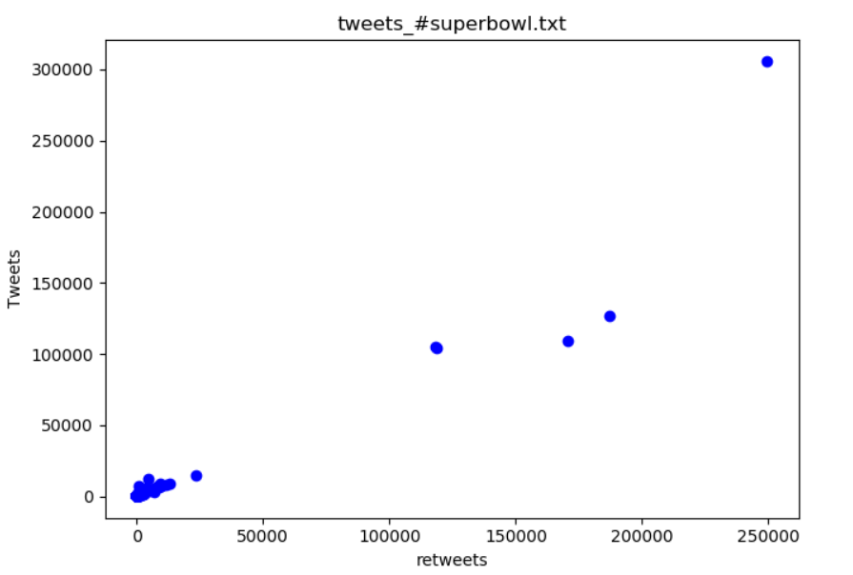

The regression coefficient is negative. However, the points on the graph follow a positive, linear relationship. Thus, the regression coefficient does not agree with the trend in the plot. This is because the regression analysis was run with several variables instead of just one. Hence, the regression coefficient does not reflect the true impact of one single variable.

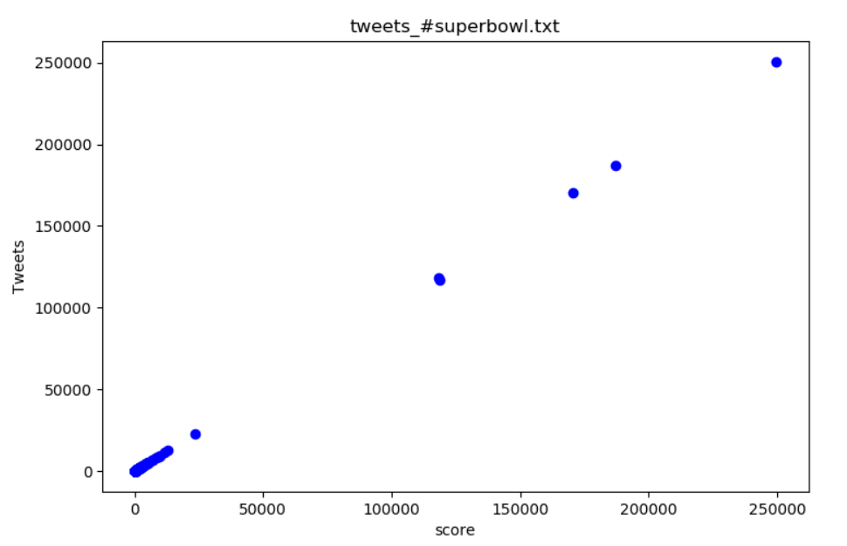

The regression coefficient is positive and the points on the graph follow a positive, linear relationship. Thus, the regression coefficient agrees with the trend in the plot.

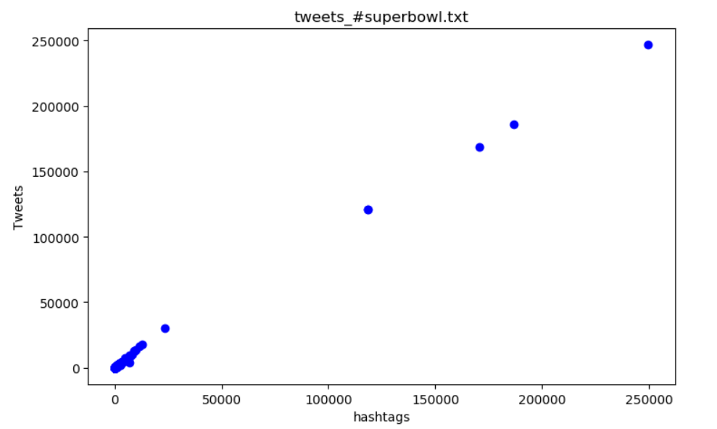

The regression coefficient is positive and the points on the graph follow a positive, linear relationship. Thus, the regression coefficient agrees with the trend in the plot.

**QUESTION 6:**

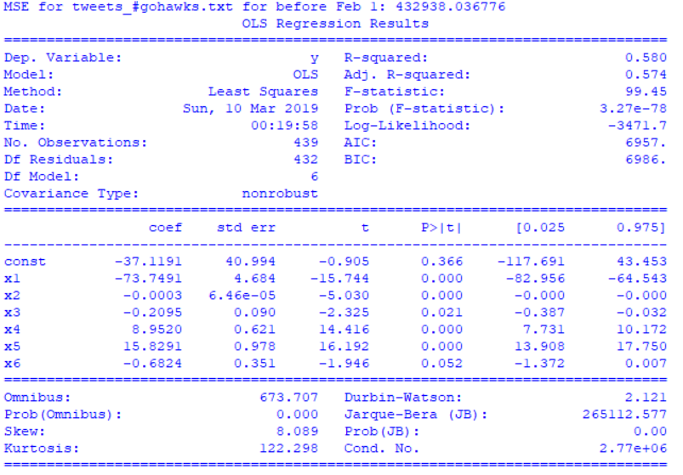

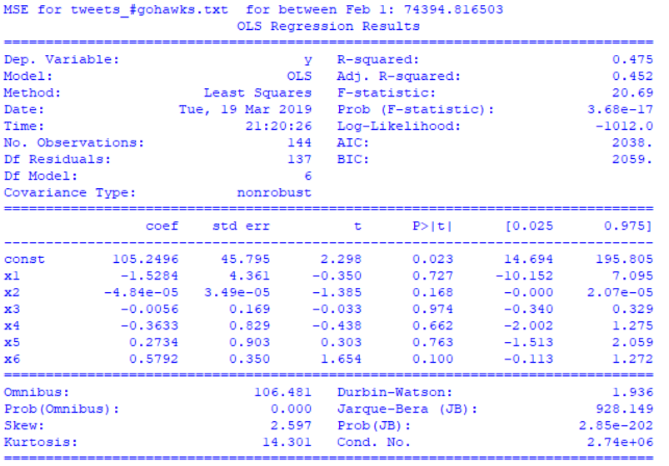

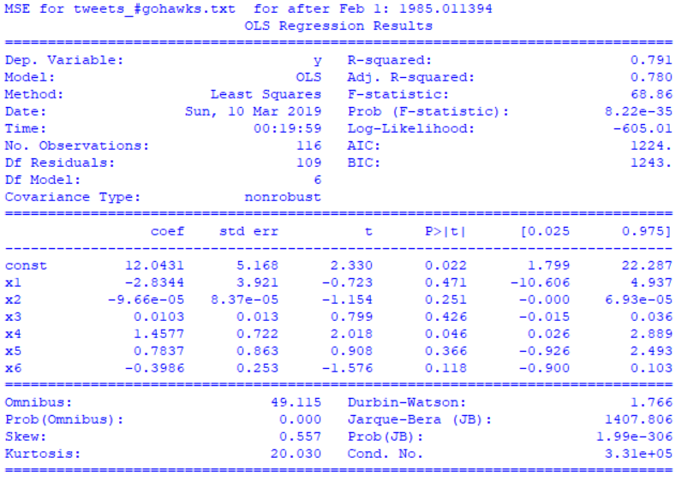

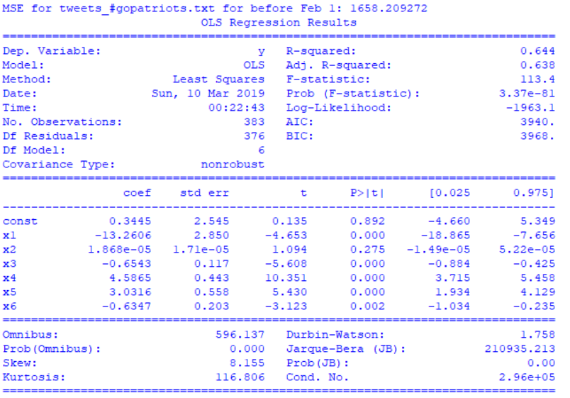

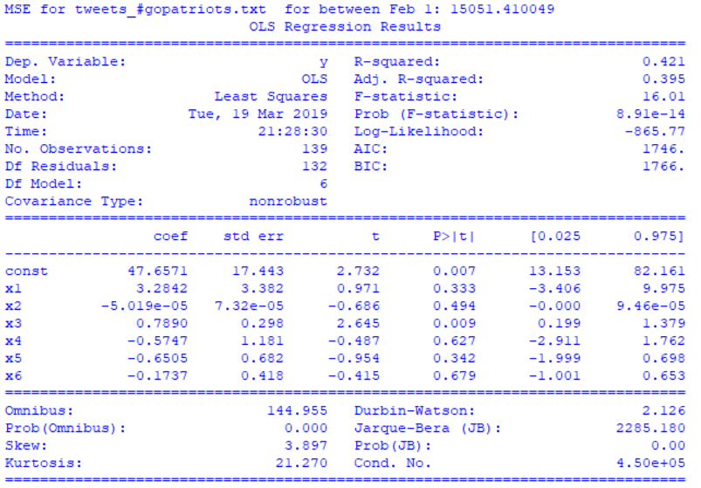

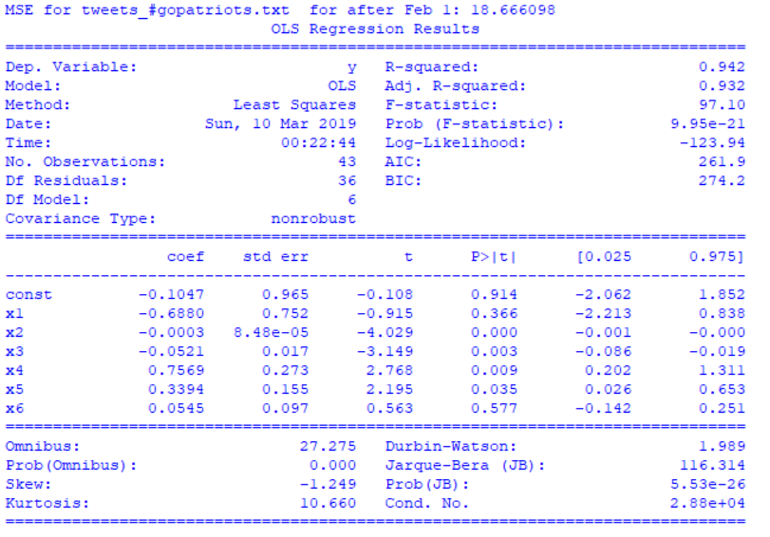

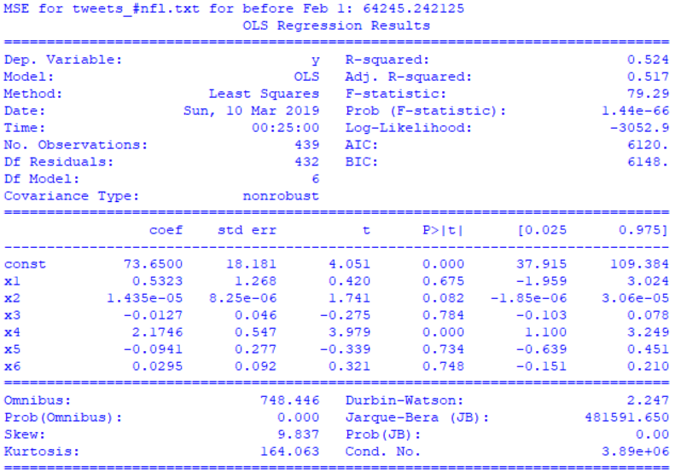

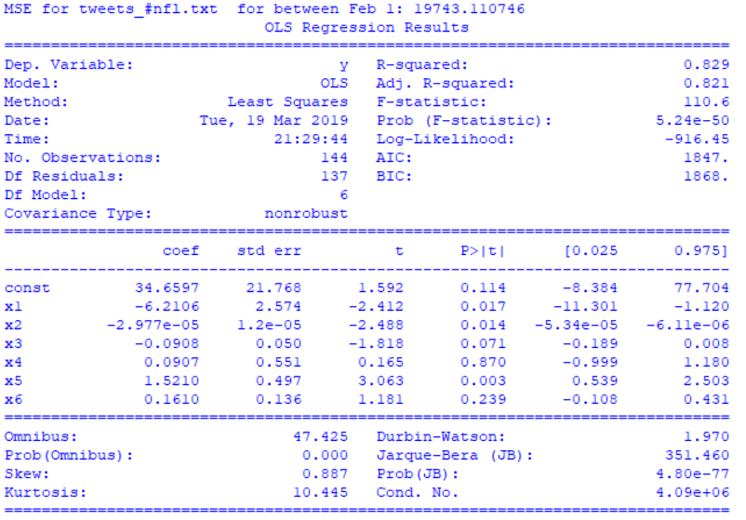

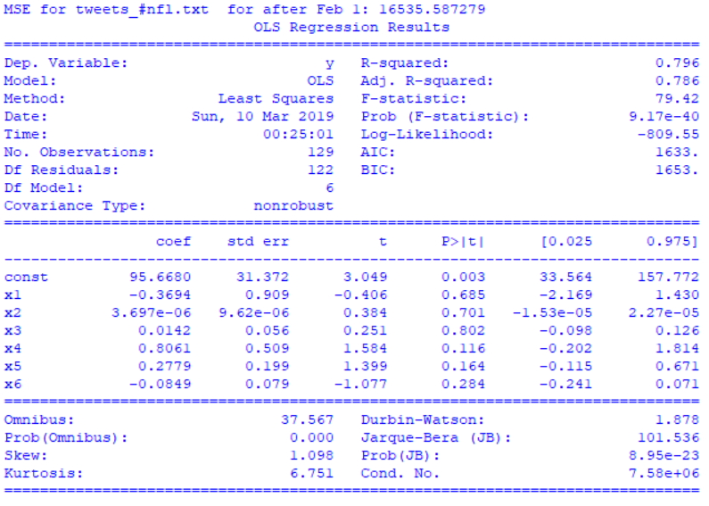

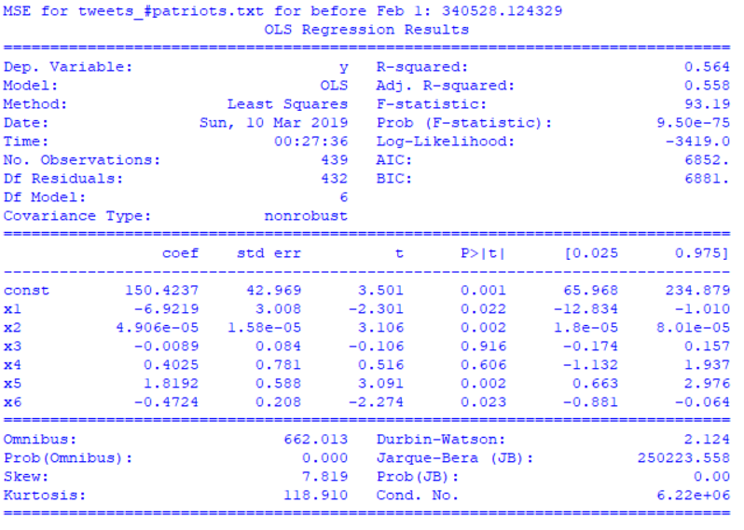

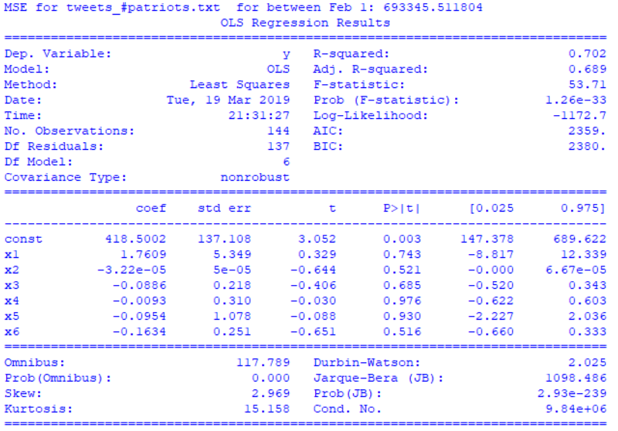

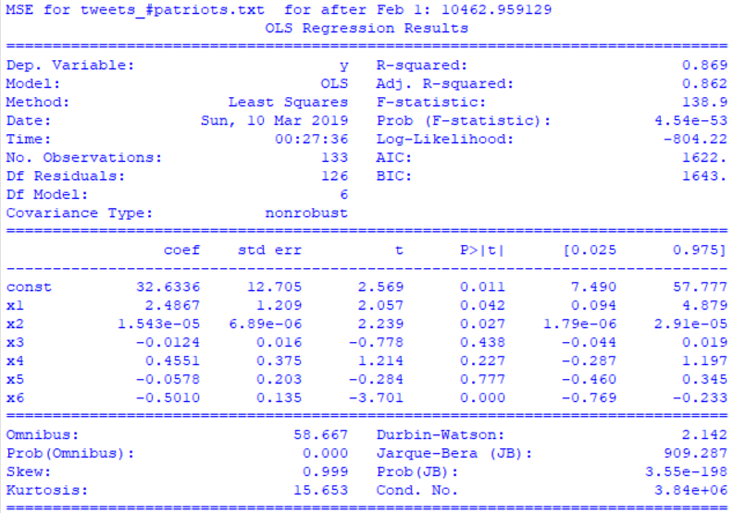

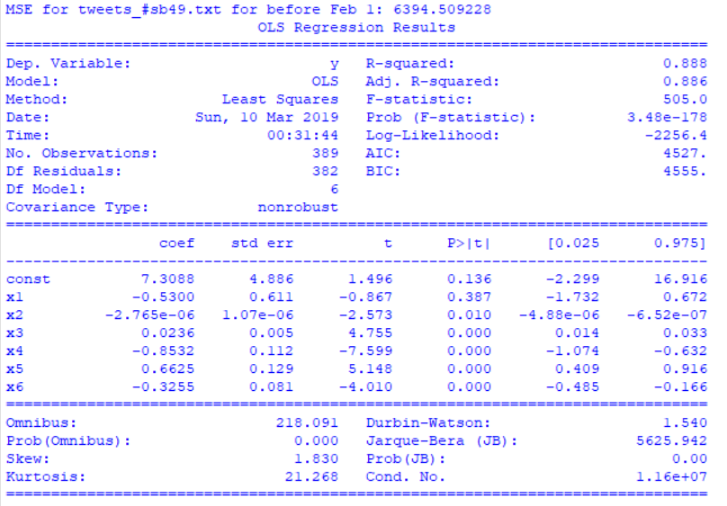

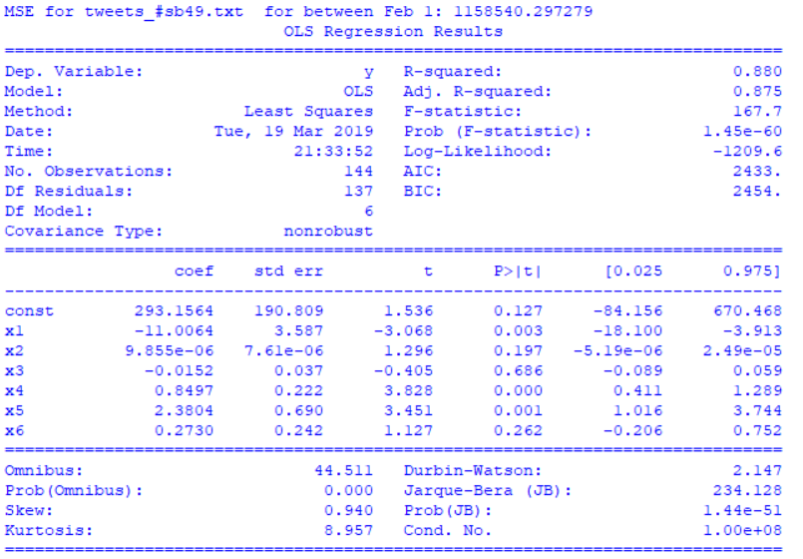

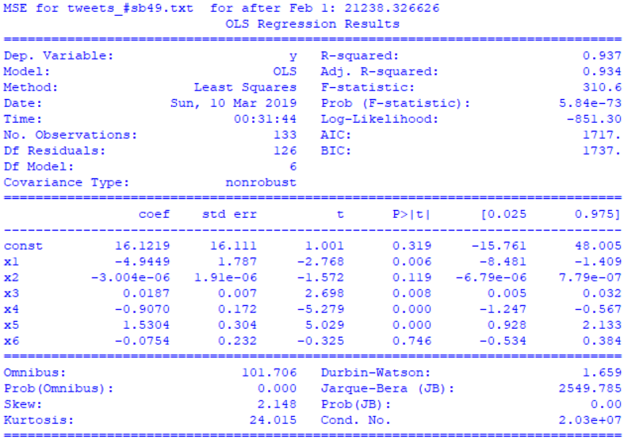

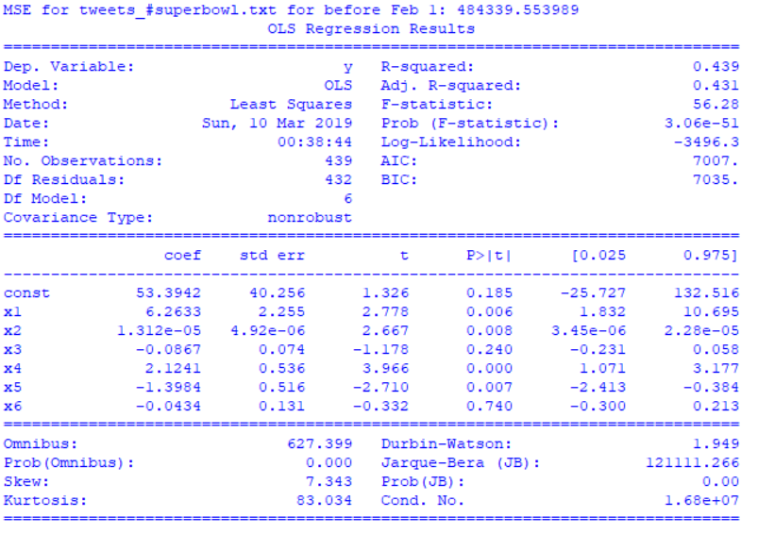

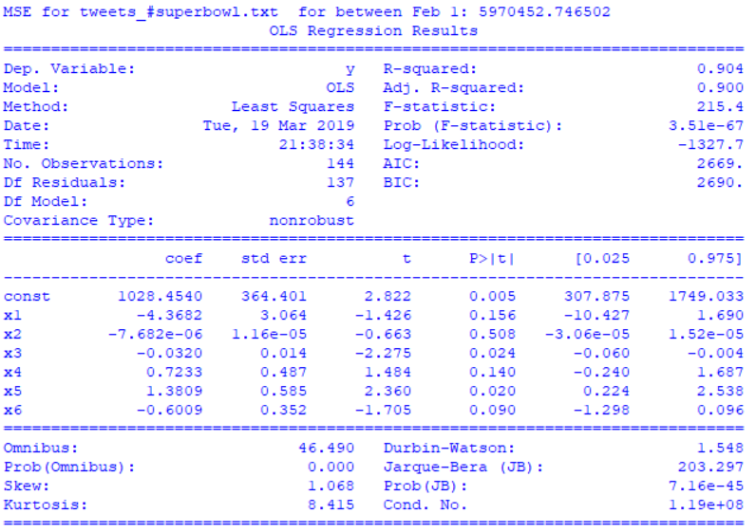

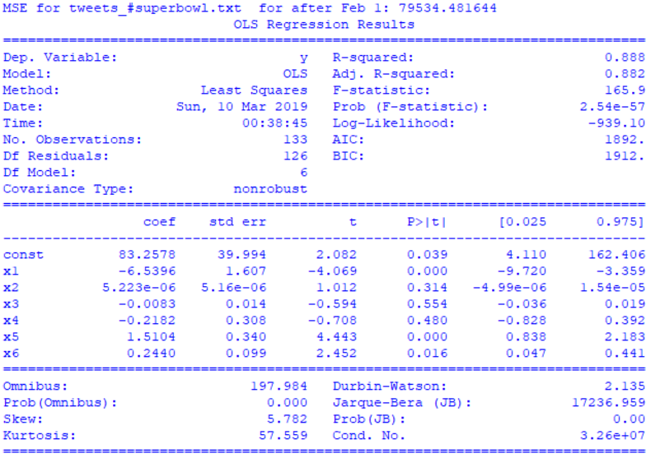

**QUESTION 7:**

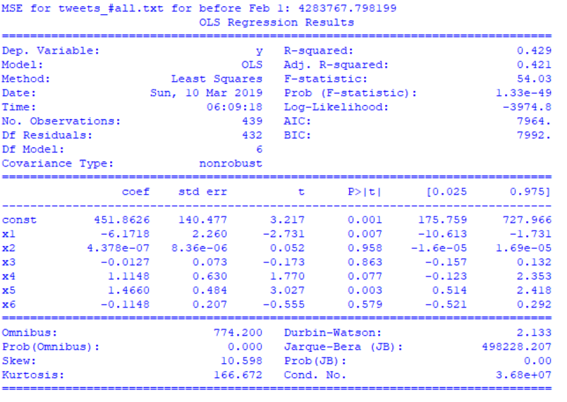

The MSE is much higher for the aggregated data than all the individual hashtags. The R-squared value is comparable to that of the #superbowl hashtag because the datasets are similar in size. The R-squared value for smaller datasets is much higher than the aggregated dataset because the model needs to learn more mappings in the aggregated dataset.

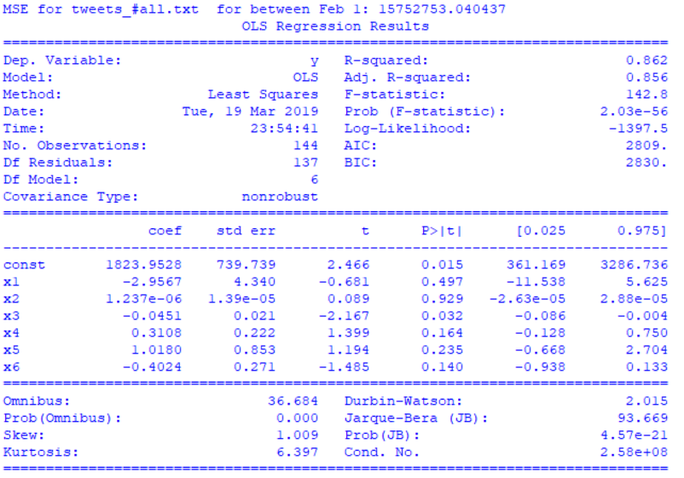

The MSE is much higher for the aggregated data than all the individual hashtags. The R-squared value is comparable to that of the #superbowl and #sb49 hashtags because the datasets are similar in size. The R-squared value for smaller datasets is much lower than the aggregated dataset because the model does not enough data to learn good mappings.

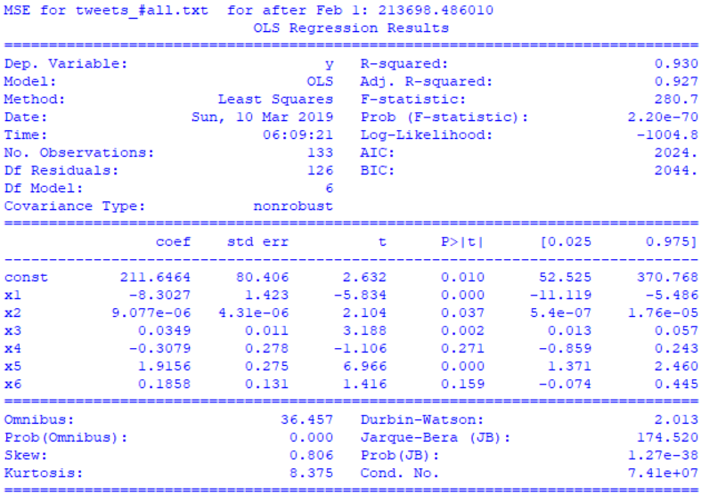

The MSE is much higher for the aggregated data than all the individual hashtags. The R-squared value is comparable to that of most of the other individual hashtags. This might be because the data for Period 3 may be similar for most of the datasets and thus the R-squared value is similar too.

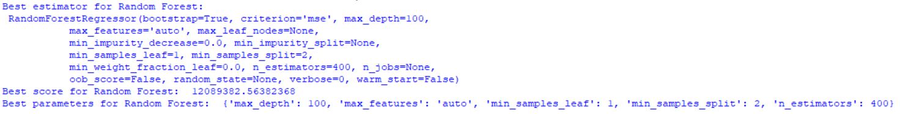**QUESTION 8:**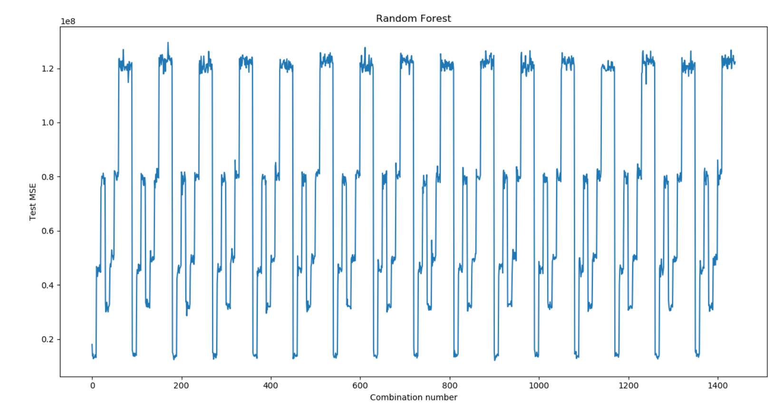

The results of the grid search are oscillatory meaning that certain combinations of the hyperparameters tends to always overfit. Thus, the test errors from cross-validation look good because they show that certain values for some parameters are not good. For instance, when the number of estimators becomes too large, the random forest starts to overfit and the test error increases. This is seen repeatedly as shown in the plot above. Therefore, it gives us the information that we should not use a very large number of estimators because they tend to overfit in all combinations and scenarios.

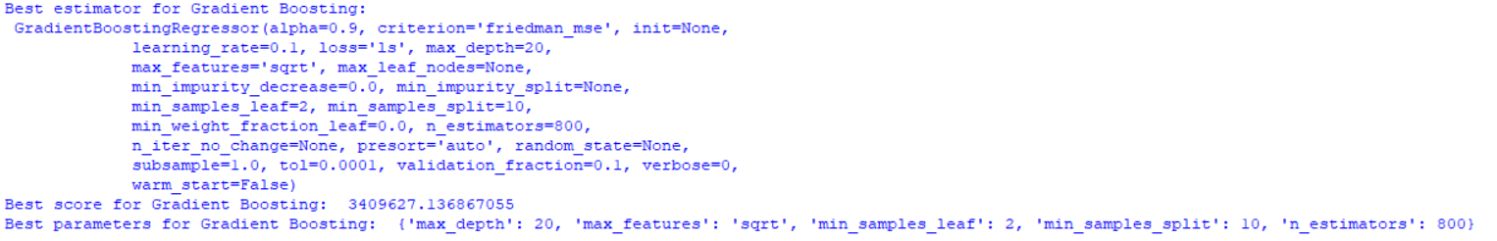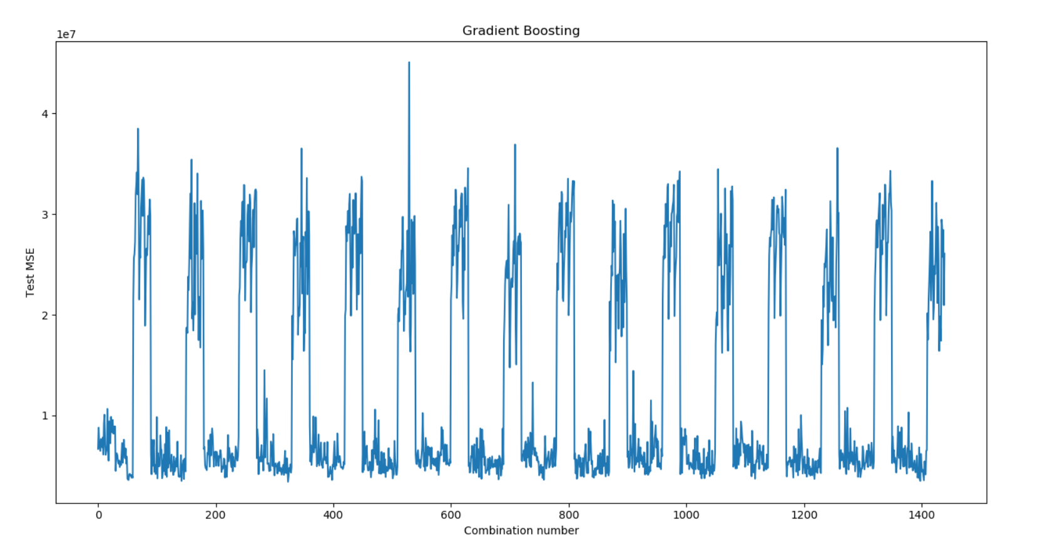

Just like the Random Forest model, the test errors from cross-validation are oscillatory suggesting that some combinations of the hyperparameters tend to overfit a lot. Again, a large number of estimators will produce overfitting. Thus, the plot above shows that certain combinations are undesirable.

Between Gradient Boosting and Random Forest, Gradient Boosting is the better estimator because it has a lower Test MSE.

**QUESTION 9:**

Using OLS,

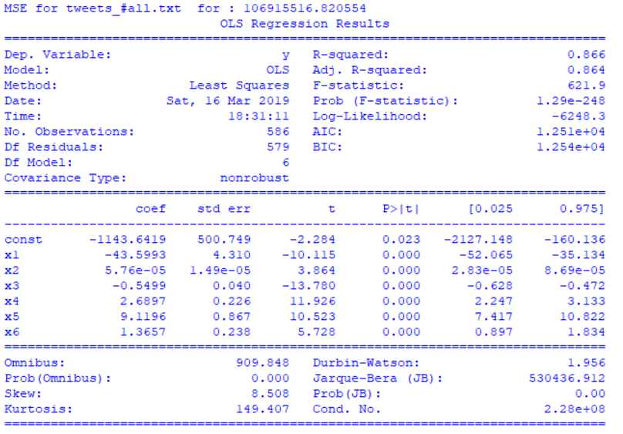

OLS has a higher Test MSE than Gradient Boosting. Thus, Gradient Boosting is the better estimator. This makes sense because Gradient Boosting is a non-linear regressor and can learn the non-linearities in the dataset which makes it a more robust estimator.

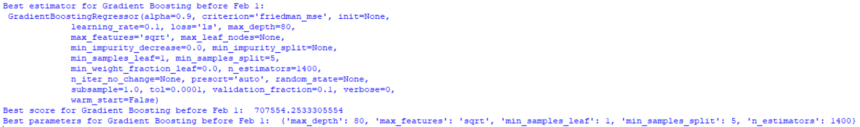**QUESTION 10:**

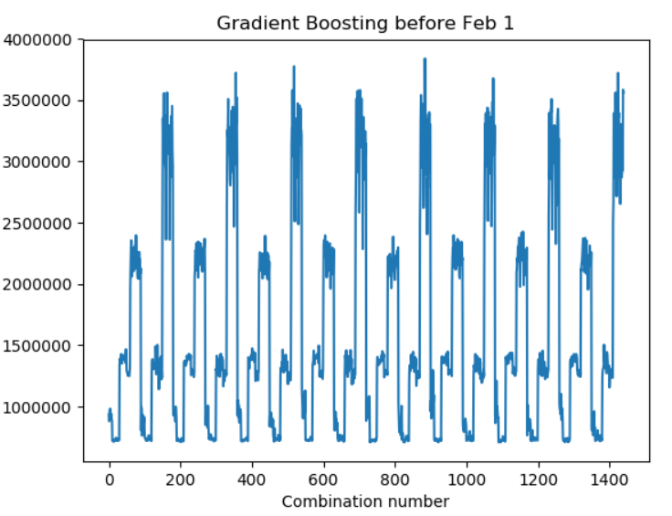

The cross-validation error has the same oscillatory behavior. However, the Test MSE is lower.

The best parameter is different than the ones I found earlier. This makes sense because the estimator is training on only a subset of the entire data and thus the parameters will most likely be different.

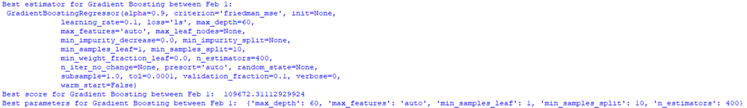

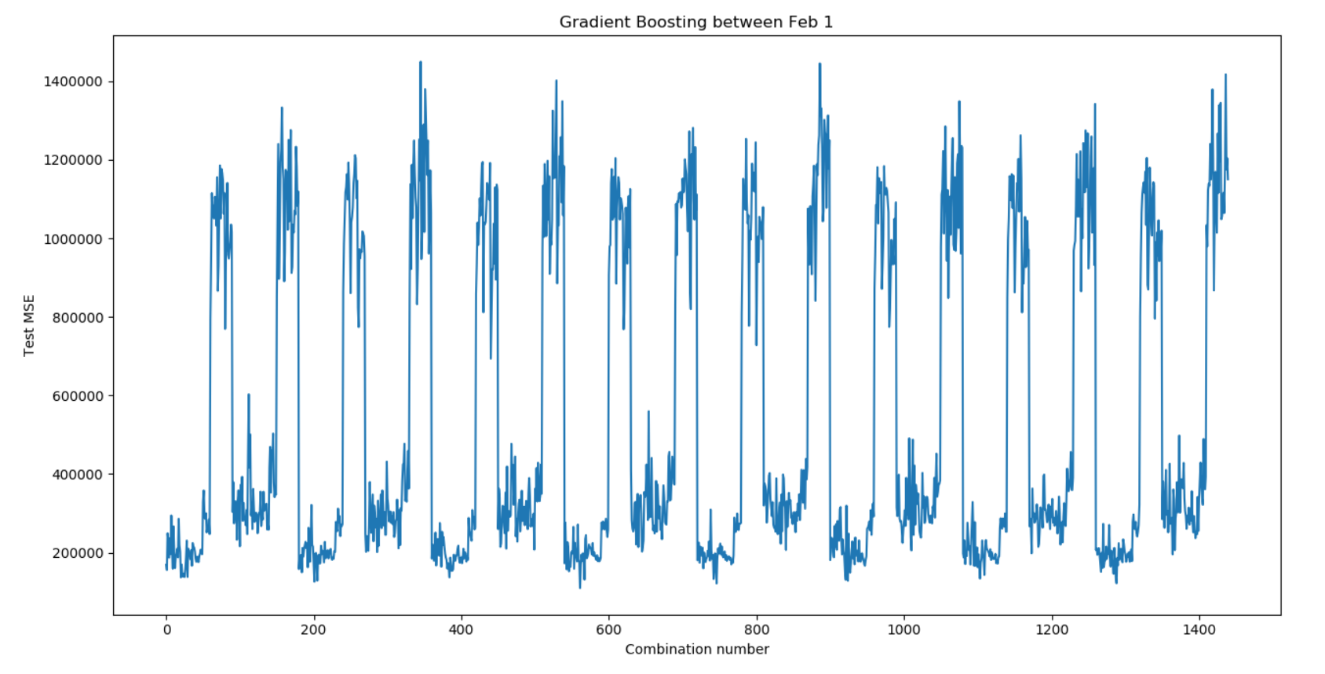

The cross-validation error has the same oscillatory behavior. However, the Test MSE is lower.

The best parameter is different than the ones I found earlier. This makes sense because the estimator is training on only a subset of the entire data and thus the parameters will most likely be different.

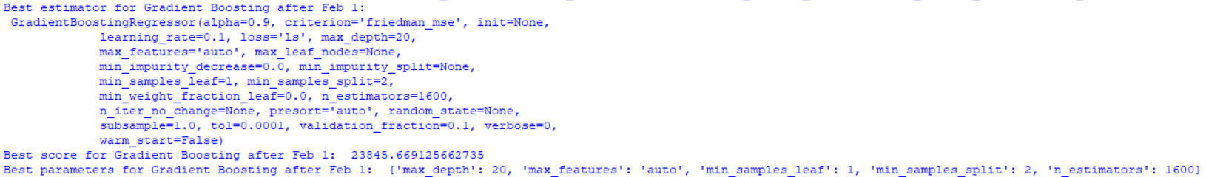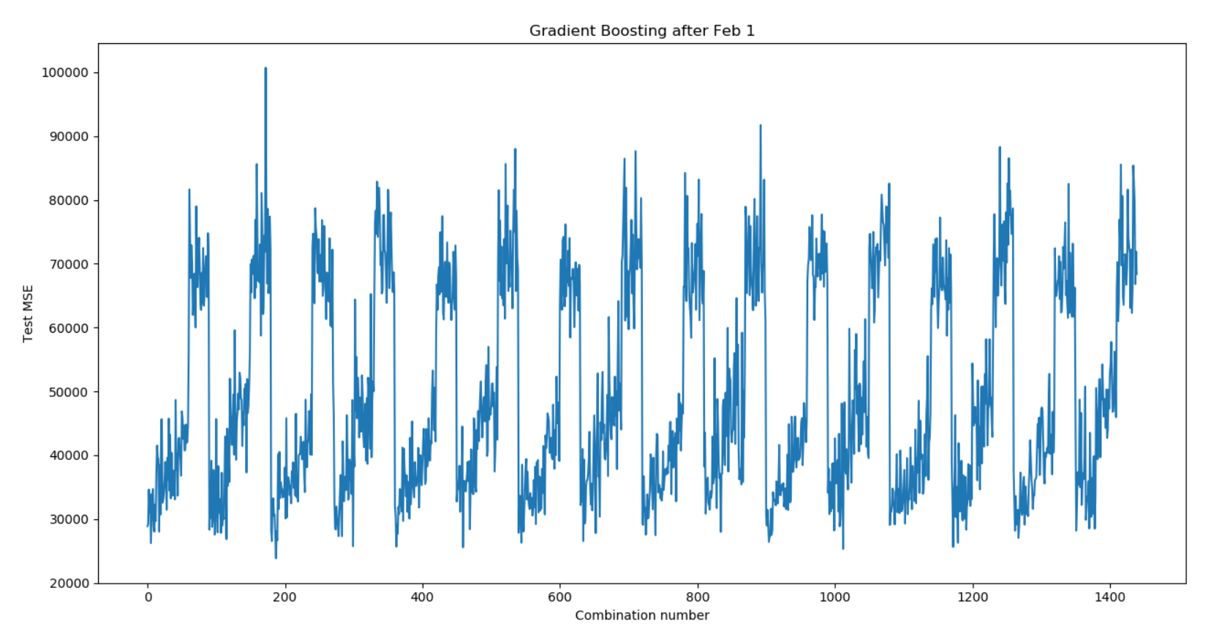

The cross-validation error has the same oscillatory behavior. However, the Test MSE is lower.

The best parameter is different than the ones I found earlier. This makes sense because the estimator is training on only a subset of the entire data and thus the parameters will most likely be different.

**QUESTION 11:**

I tried out the following param_grid:

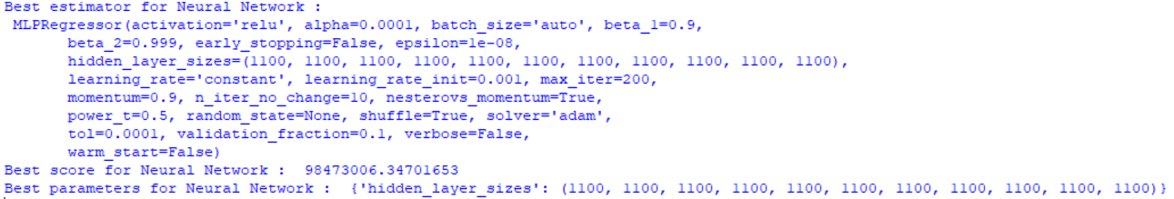param = {'hidden_layer_sizes':[(100,), (200,200,), (300,300,300,), (400,400,400,400,),(500,500,500,500,500,), (600,600,600,600,600,600,), (700,700,700,700,700,700,700,), (800,800,800,800,800,800,800,800,), (900,900,900,900,900,900,900,900,900,), (1000,1000,1000,1000,1000,1000,1000,1000,1000,1000,), (1100,1100,1100,1100,1100,1100,1100,1100,1100,1100,1100,), (1200,1200,1200,1200,1200,1200,1200,1200,1200,1200,1200,1200,)]}

Each combination number refers to the number of layers in the neural network. The number of neurons in each layer is equal to 100*combination number.

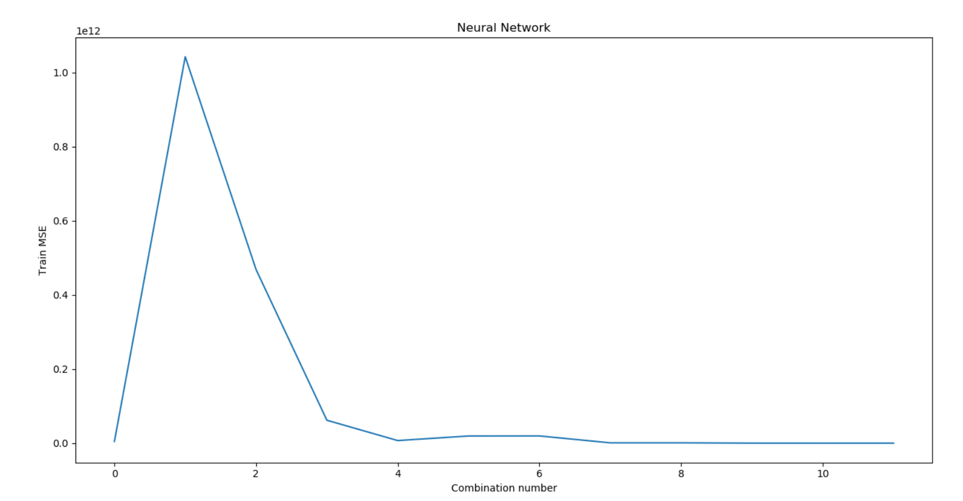

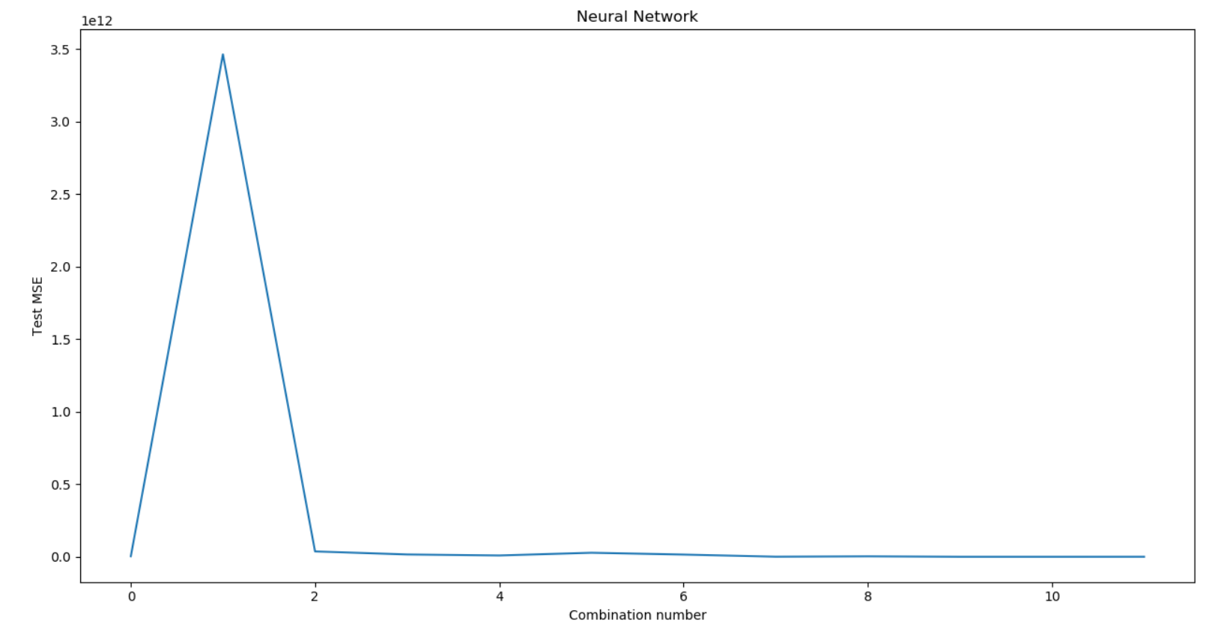

**QUESTION 12:**



Yes, the performance does increase because normalizing the inputs reduces the effect of the vanishing-gradients phenomenon when training neural networks.

**QUESTION 13:**

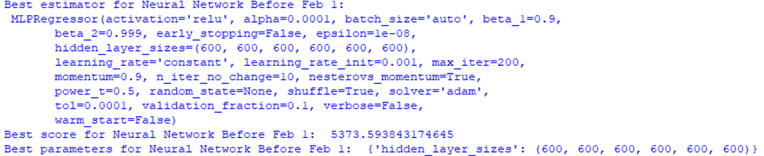

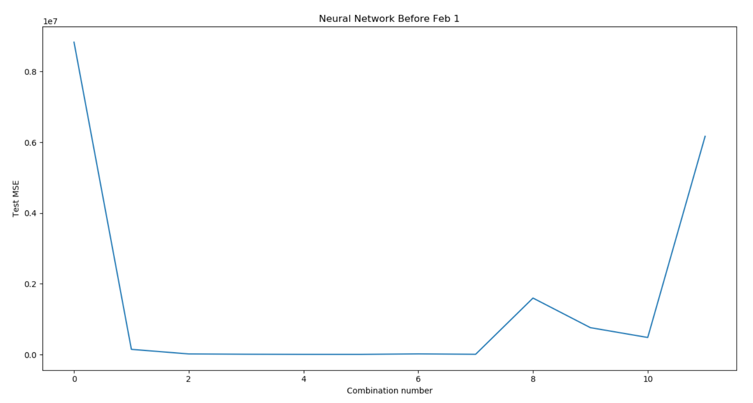

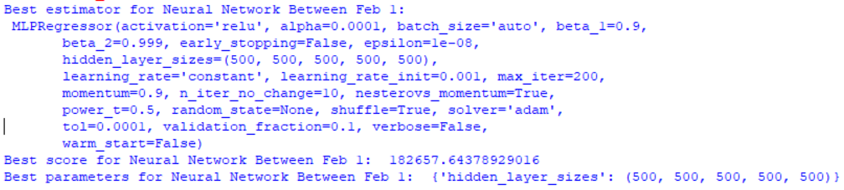

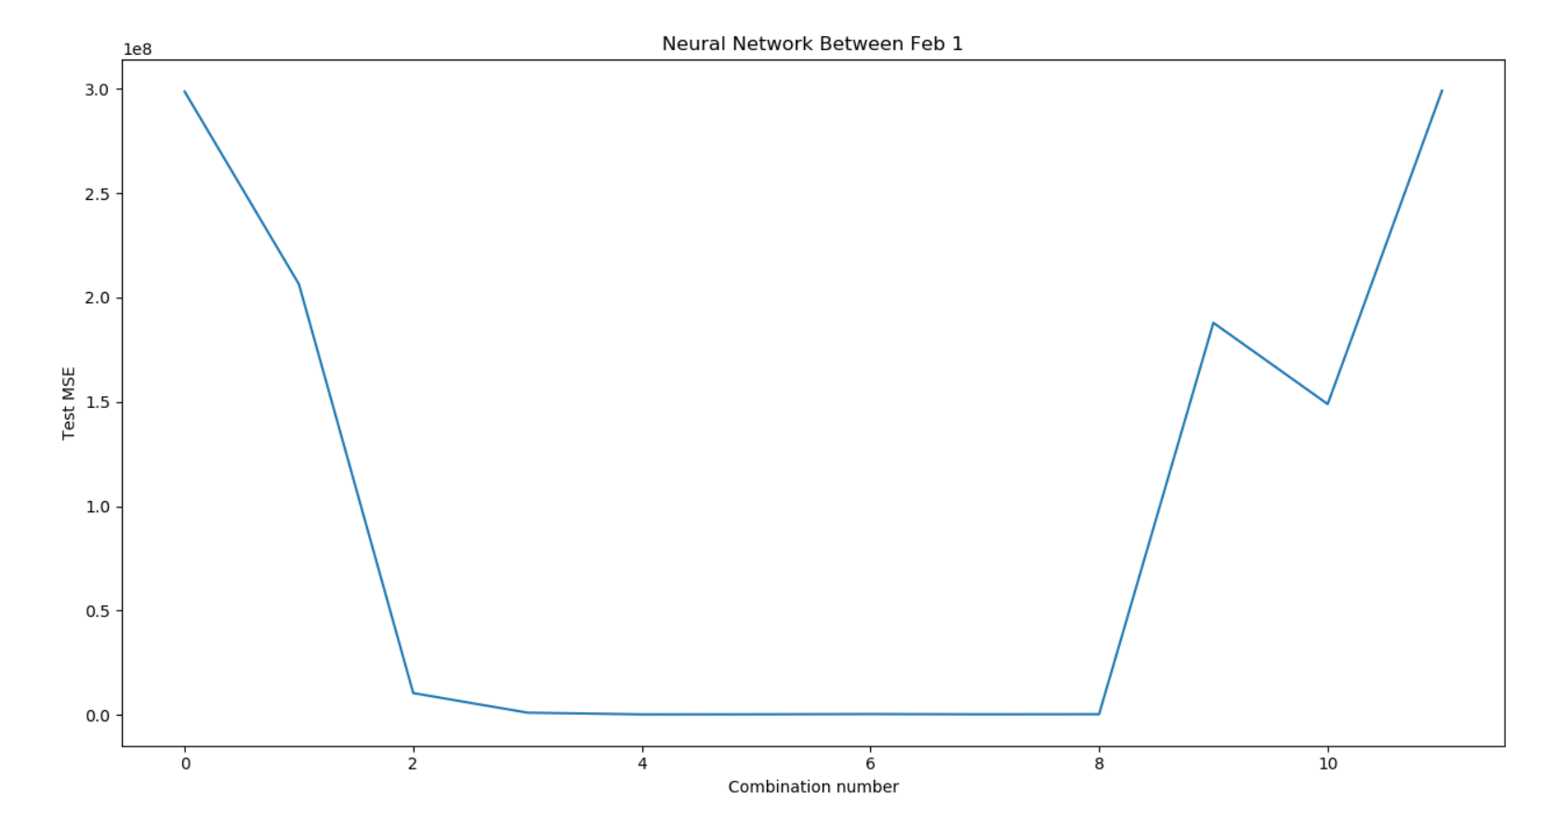

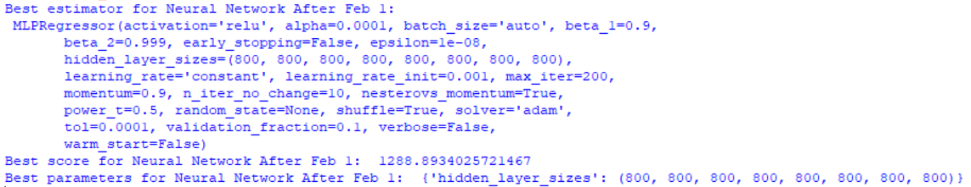

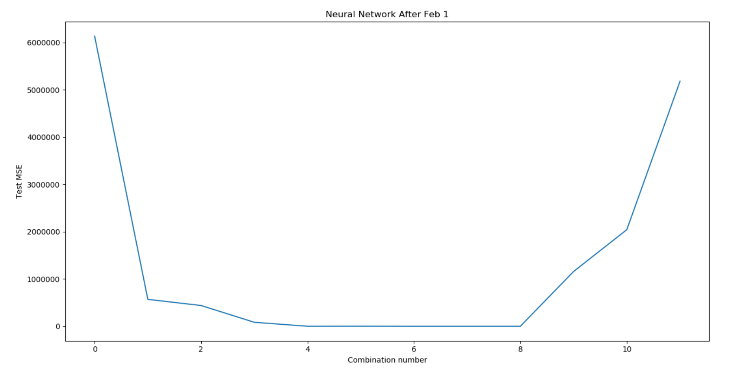

**QUESTION 14:**



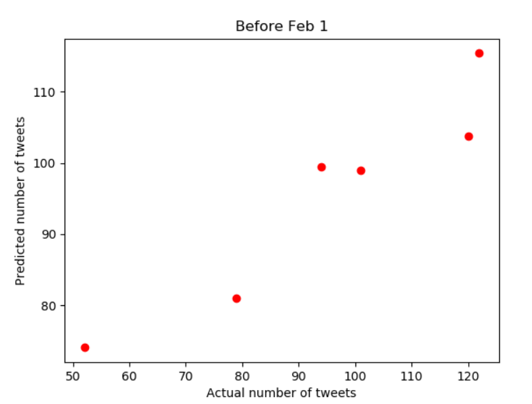



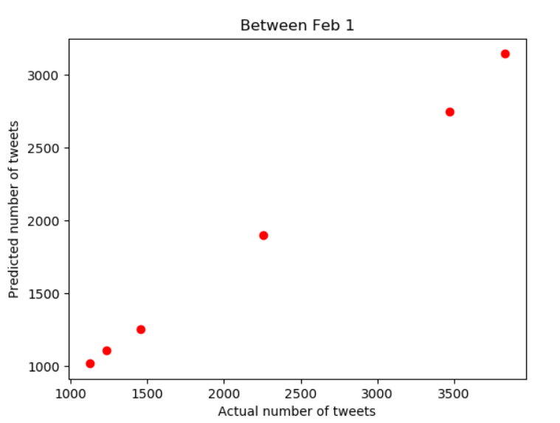



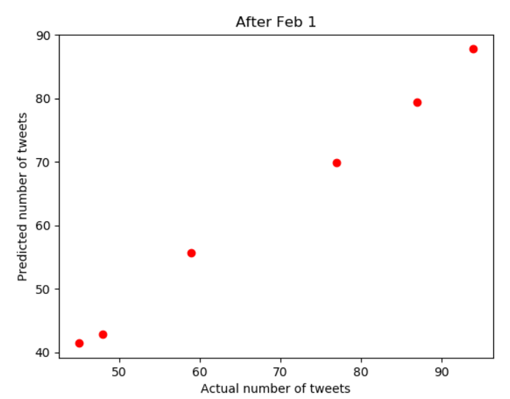



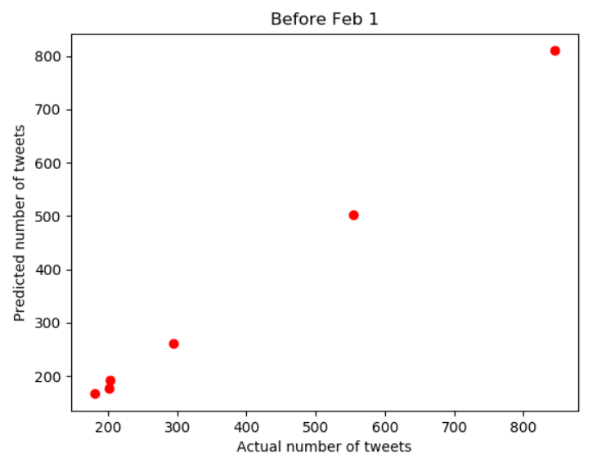



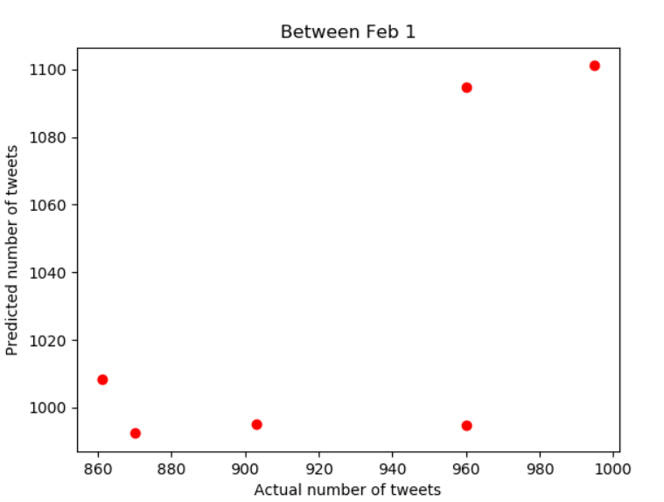



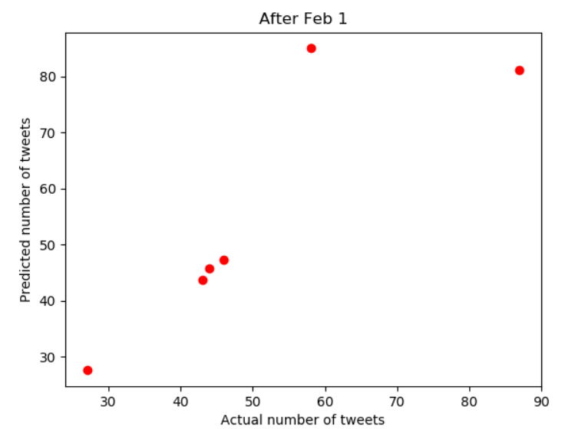



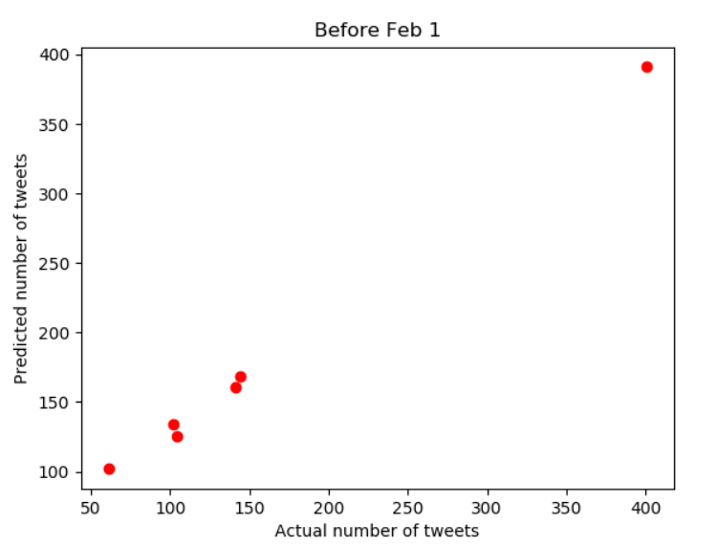



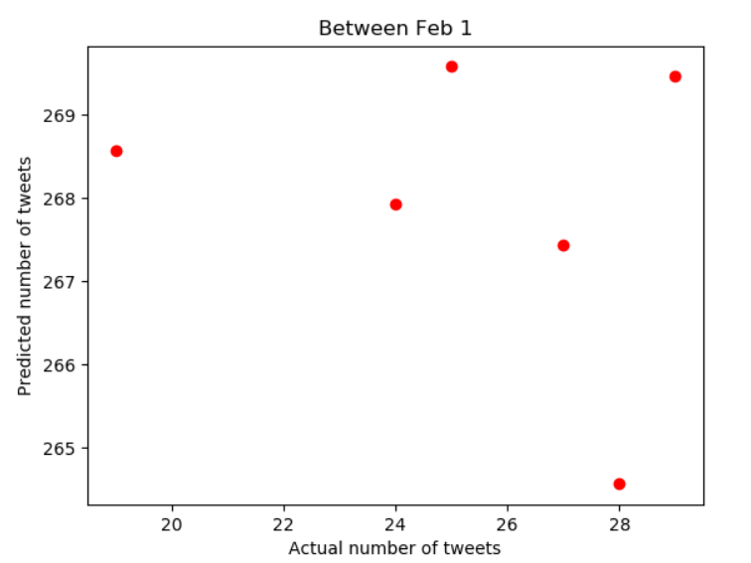



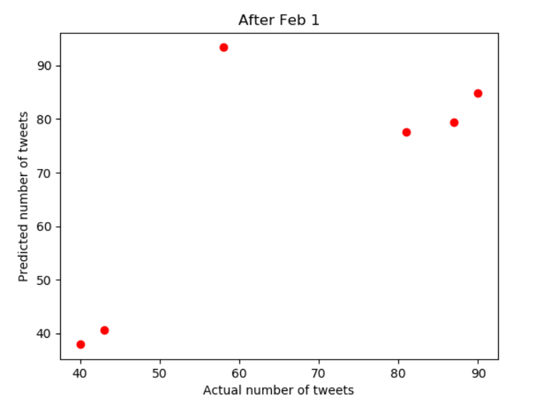

**QUESTION 15:**

To determine whether the location is in Washington, Massachusetts or neither, I used the title of the tweet to give me some information. I took all the tweets from the #superbowl hashtag dataset and divided into three categories: Washington, Massachusetts or neither. Then, I cleaned the tweets and extracted features from them using methods that I used for Project 1. After extracting features, I performed dimensionality reduction using SVD. After that, I trained 3 binary classifier that I have used in Project 1: Logistic Regression, Linear SVM and Gaussian Naïve Bayes. Finally, I assessed the performance of the classifiers using accuracy, recall, precision, F1 score, confusion matrix and ROC curve.

Below is the summary of the steps I used to determine the location:

1. Extract all tweets from the #superbowl hashtag dataset
2. Extract location and title from the tweets
3. Label title as 1 if location is Massachusetts. Otherwise, label the title 0.
4. Clean the titles
5. Extract features from the titles using lemmatization and TF-IDF
6. Perform dimensionality reduction using SVD
7. Train 3 classifiers using 5-fold cross-validation: Logistic Regression, Linear SVM and Gaussian Naïve Bayes
8. Assess performance of the classifier using various metrics

After training and testing the classifiers, Gaussian Naïve Bayes was the worst classifier. Logistic regression and Linear SVM had very comparable performance. However, logistic regression was very slightly better than Linear SVM.

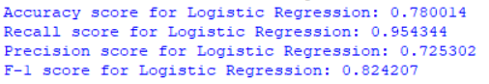

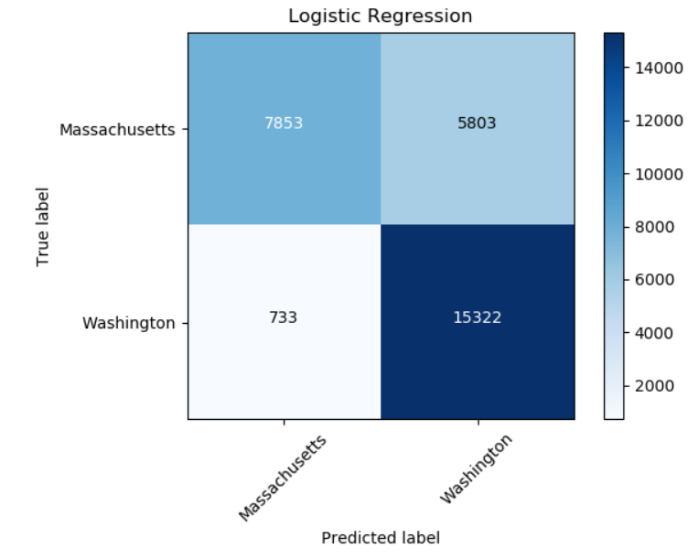

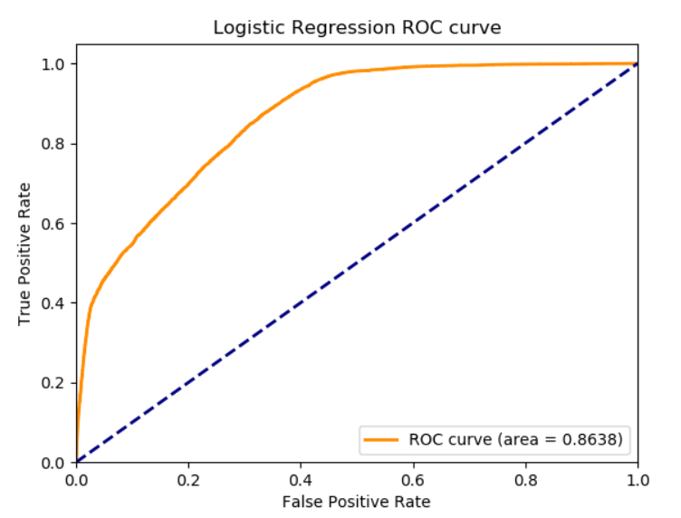

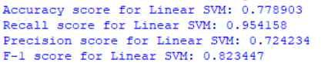

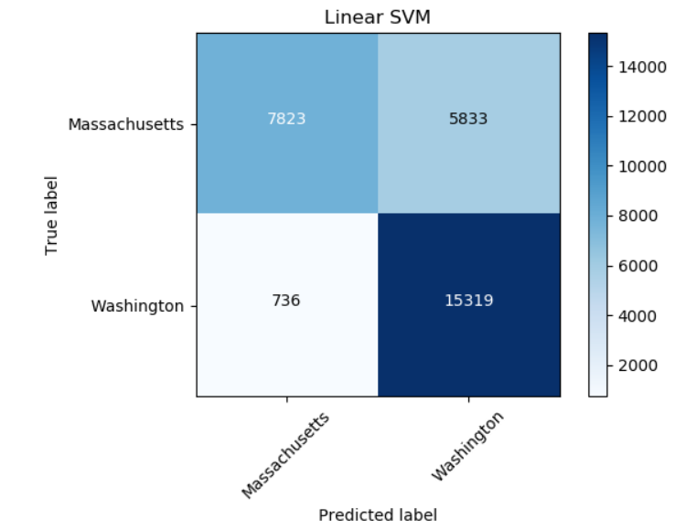

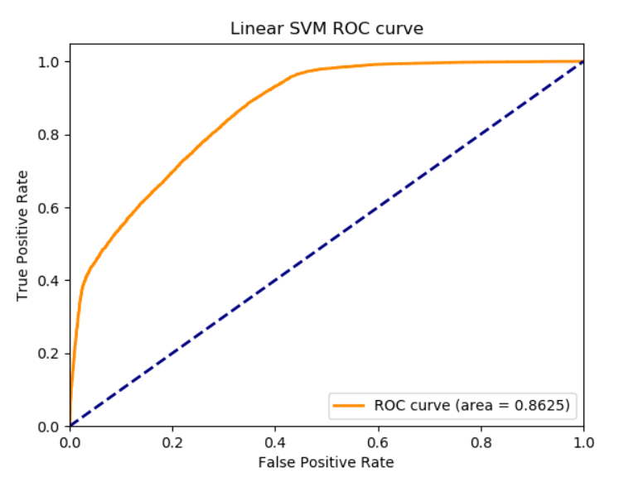

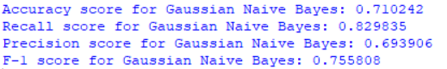

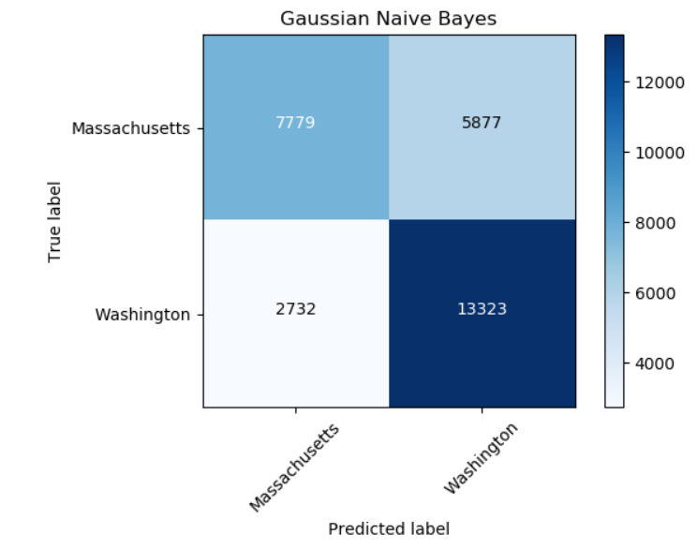

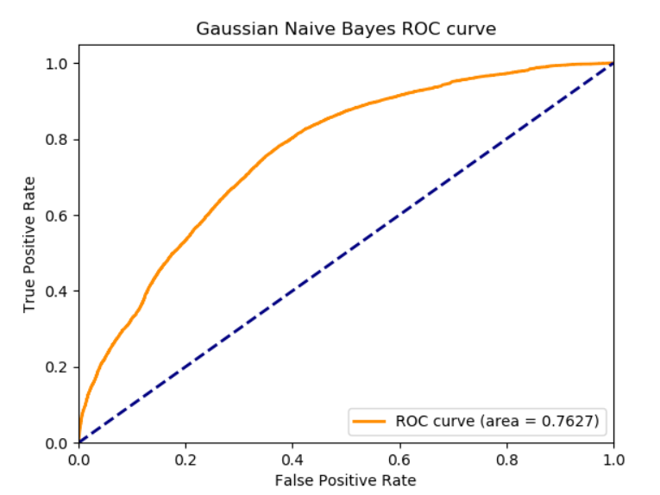

**QUESTION 16:**

The question I would like to ask and answer is: To what extent do highly influential tweets (measured by number of tweets, number of followers, number of retweets and number of impressions) introduce a change in the general Twitter sentiment level? I will tackle this problem during the time period of 3:00 PM to 9:00 PM on 1st Feb using 5-min time windows.

I measure sentiment level using the SentimentIntensityAnalyzer() function from the NLTK library. Specifically, I use the ‘compound’ score. In general, the higher the ‘compound’ score the more positive the sentiment level.

To explore the effects of the number of impressions, I plotted the number of impressions and sum of ‘compound’ scores.

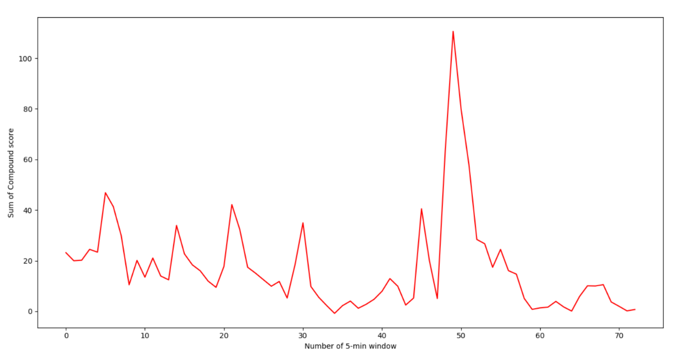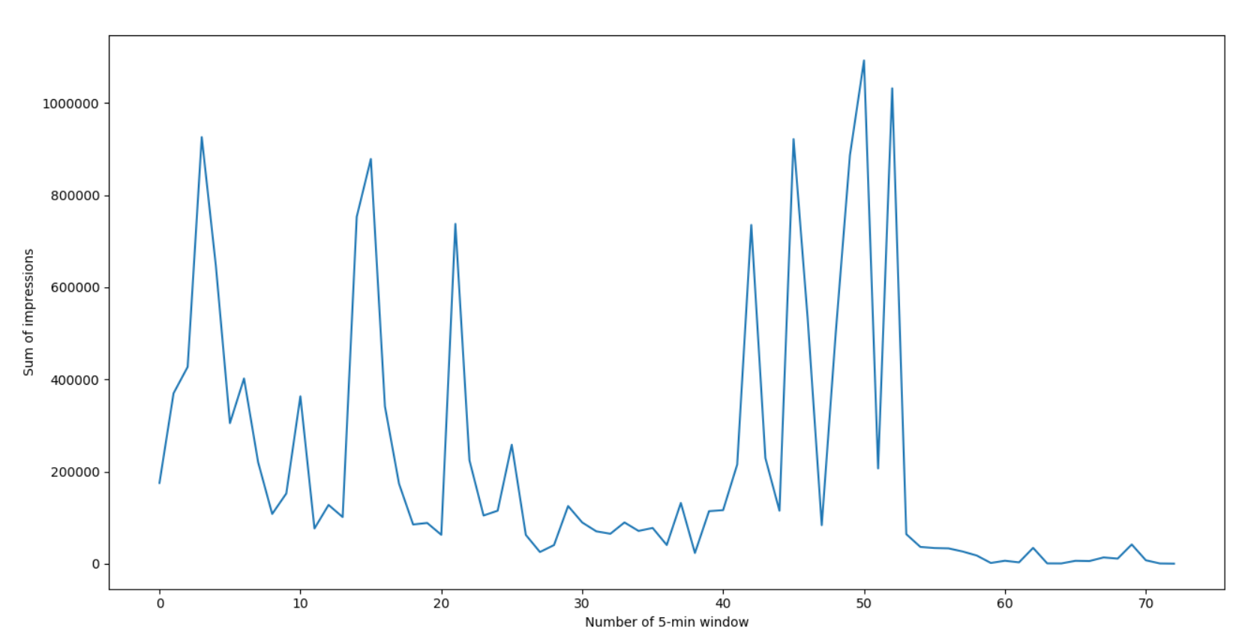

As it can be seen, spikes in the number of impressions are mirrored by spikes in ‘compound’ scores. This suggests that there is a relationship between the number of impressions and the overall sentiment level. This is because a highly influential tweet could change other people’s thoughts and opinions. Thus, this would induce a change in the overall sentiment level.

Summary of what I did:

1. Model = Neural network regression model
2. Input features = number of tweets, number of followers, number of retweets and number of impressions
3. Output to be predicted = sum of the ‘compund’ scores since this represents the collective, overall sentiment level.
4. Method = grid seaerch 5-fold cross-validation to find the best architecture
5. Training dataset = #nfl hashtag dataset
6. Test dataset = #gopatriots and #gohawks hashtag datasets

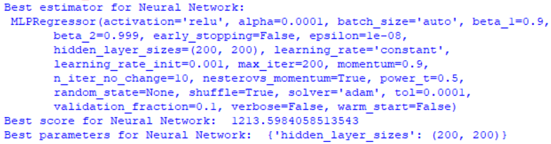



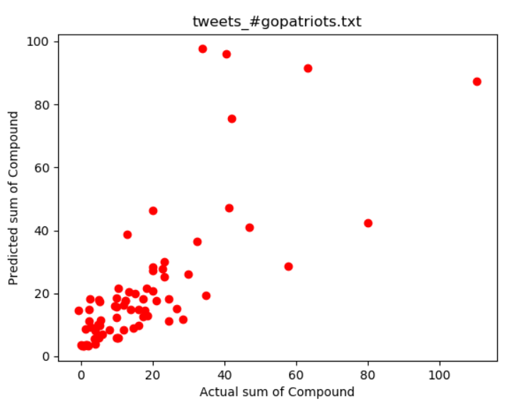



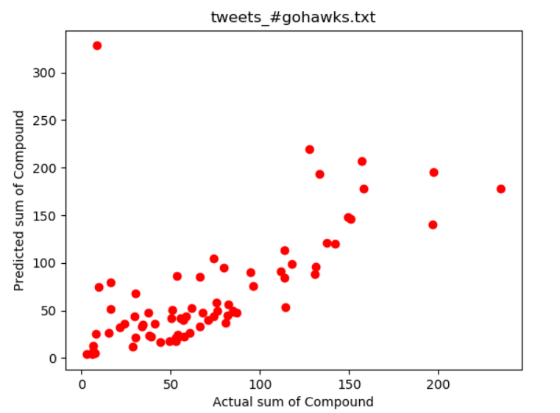

As it can be seen from the plots above, there is an intermediate-strength linear relationship between the true and predicted values. Therefore, this suggests that highly influential tweets to affect the overall sentiment level to a large extent and degree. One of the major factors that dictate the overall sentiment level is the number of impressions.